ARKcASE
tRAINING gUIDE
For User Admin Training Participants
Abstract
This training will provide you with base knowledge you will need to begin working with ArkCase.




A New Breed of Enterprise Case Management
A New Breed of Enterprise Case Management

Table of Contents

1 ArkCase Installation 3
1.1 Global Architecture 3
1.2 Architecture for this training 3
1.3 (ONLY FOR THIS TRAINING) Connect to the development VM 3
1.4 Start setting up the machine 4
1.5 Install Components 4
1.6 Download Training Materials 6
1.7 Configure Components 6
1.8 Tomcat TLS Configuration 7
1.9 Component Verification 7
1.10 Download ArkCase, Configuration and Docker services from GitHub 8
1.11 Build and start ArkCAse 9
2 Extensibility 22
2.1 Overview 22
2.2 Create Extension project 23
2.3 Extend Complaint.java Class 24
2.4 Extend Complaint Database Table 27
2.5 Update configuration to accept new package with Entity 27
2.6 Register new ExtComplaint entity under Diff Service 28
2.7 Extend Complaint Solr Transformer 29
2.8 Extend Complaint UI 32
2.9 Build and Start Complaint Extension 34
3 Create New ArkCase Module 35
3.1 Comment Entity 35
3.2 User Interface (UI) 38
3.3 Configuration 41

ArkCase Installation

Setting Up ArkCase

Global Architecture
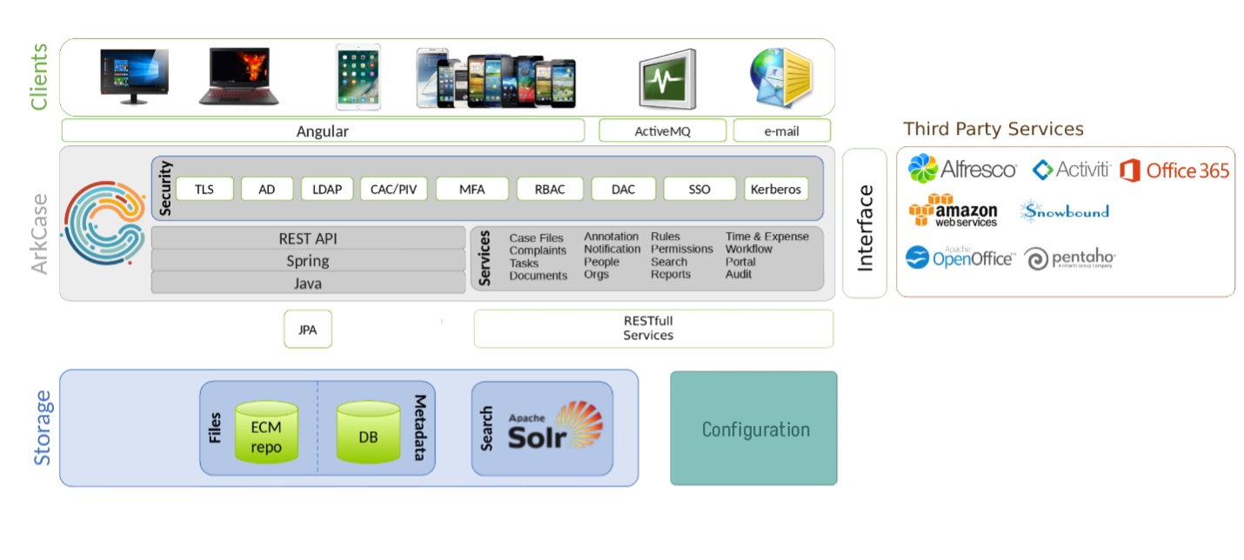

Architecture for this training
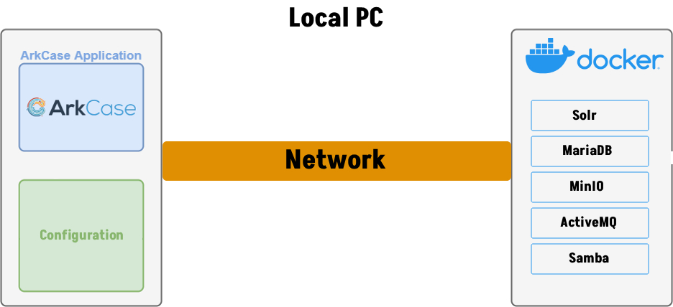

(ONLY FOR THIS TRAINING) Connect to the development VM

We will be working remotely with the development machines. Each of you should open a Remote Desktop application. If you are using a Mac, please install the Windows App.

Enter the IP address on port 5901 in the following format: <IP_ADDRESS>:5901
When prompted for credentials, please enter:
- Username: ubuntu
- Password: arkcase-training-2026!
When prompted for certificate, click Yes or Continue.

Start setting up the machine

For training purposes let’s use one folder where we will work and install ArkCase and needed components. Let’s create one folder named training (we will call {training.folder} in the next pages):

- Windows
  - C:Users/<USERNAME>/training
- MacOS
  - /Users/<USERNAME>/training
- Ubuntu
  - /home/<USERNAME>/training

Next, let’s start with downloading and installing all needed components for successful installation:

Install Components

- Install Git
  - https://git-scm.com/downloads
  - Ubuntu
    - apt-get install git
- Install OpenJDK 17.0.18+8
  - https://www.openlogic.com/openjdk-downloads
  - Ubuntu
    - sudo apt install openjdk-17-jdk
- Install Tomcat 9.0.115
  - Main download URL: https://downloads.apache.org/tomcat/
  - Windows/Mac:
    - https://downloads.apache.org/tomcat/tomcat-9/v9.0.117/bin/apache-tomcat-9.0.117.zip
  - Ubuntu:
    - wget https://downloads.apache.org/tomcat/tomcat-9/v9.0.117/bin/apache-tomcat-9.0.117.tar.gz
  - Extract the content of apache-tomcat-9.0.117.zip in the {training.folder}
  - Ubuntu
    - tar -xzf apache-tomcat-9.0.117.tar.gz
  - At the end, Tomcat folder installation should be {training.folder}/apache-tomcat-9.0.117 and bin folder should be {training.folder}/apache-tomcat-9.0.117/bin (this is confirmation that you extracted tomcat on a proper way)
- Install Maven (3.9+)
  - Main download URL: https://maven.apache.org/download.cgi
  - Windows/Mac:
    - https://dlcdn.apache.org/maven/maven-3/3.9.14/binaries/apache-maven-3.9.14-bin.zip
  - Ubuntu:
    - wget https://dlcdn.apache.org/maven/maven-3/3.9.14/binaries/apache-maven-3.9.14-bin.tar.gz
  - Extract the content of apache-maven-3.9.14-bin.zip in the {training.folder}
  - Ubuntu:
    - tar -xzf apache-maven-3.9.14-bin.tar.gz
  - At the end, Maven folder installation should be {training.folder}/apache-maven-3.9.14 and bin folder should be {training.folder}/apache-maven-3.9.14/bin (this is confirmation that you extracted tomcat on a proper way)
- Install Docker Desktop
  - Docker Desktop: https://www.docker.com/products/docker-desktop/
  - Ubuntu
    - (SKIP IF FIRST TIME INSTALLING) sudo apt remove -y docker-desktop
    - (SKIP IF FIRST TIME INSTALLING) sudo apt remove -y docker.io docker-doc docker-compose docker-compose-v2 podman-docker containerd runc
    - sudo apt update
    - sudo apt install -y ca-certificates curl gnupg
    - sudo install -m 0755 -d /etc/apt/keyrings
    - curl -fsSL https://download.docker.com/linux/ubuntu/gpg | sudo gpg --dearmor -o /etc/apt/keyrings/docker.gpg
    - sudo chmod a+r /etc/apt/keyrings/docker.gpg
echo \
"deb [arch=$(dpkg --print-architecture) signed-by=/etc/apt/keyrings/docker.gpg] https://download.docker.com/linux/ubuntu \
$(. /etc/os-release && echo "$VERSION_CODENAME") stable" | \
sudo tee /etc/apt/sources.list.d/docker.list > /dev/null
    - sudo apt update
    - sudo apt install -y docker-ce docker-ce-cli containerd.io docker-buildx-plugin docker-compose-plugin
    - hash -r
    - sudo systemctl enable docker
    - sudo systemctl start docker
- Install Node.js version 16.20.2
  - https://nodejs.org
  - Ubuntu
    - curl -o- https://raw.githubusercontent.com/nvm-sh/nvm/v0.40.4/install.sh | bash
    - \. "$HOME/.nvm/nvm.sh"
    - nvm install 16
- Install npm version: 8.19.4
  - will be installed automatically with Node.js
- Install Yarn version 1.22.XX
  - https://yarnpkg.com/en/docs/install
  - Ubuntu
    - npm install --global yarn
- Install IDE (Intellij IDEA, STS or any IDE that you are familiar with for Java programming. NOTE: For this training purposes, we will use Intellij IDEA evaluation copy. If you choose to use different IDE, then you should change some steps below corresponding your IDE choice):
  - https://www.jetbrains.com/idea/download/

Download Training Materials
- Open Git Bash/Terminal and go to the folder {training.folder} with the following command
  - cd {training.folder}
- Download Documentation from GitHub:
  - Clone the Documentation repository
    - git clone https://github.com/ArkCase/ArkCase_Training_Documentation.git
    - Enter your GitHub credentials if asked
  - Checkout the main branch
    - git checkout main

Configure Components
After installing every component from point 1.3, we need to configure some of them. Please follow below instructions to configure them:
- Check/Set JAVA_HOME environment variable, pointing to the top-level JDK (not the JRE) folder
- Update your PATH environment valuable to include the Maven bin folder
  - In our case the value added to the PATH variable should be {training.folder}/apache-maven-3.9.14/bin
  - MacOS
    - Update .profile to set the path
      - export PATH=$PATH:{training.folder}/apache-maven-3.9.14/bin
    - Load .profile for changes to have effects
      - source .profile
  - Ubuntu - at the end of the bashrc file, add the export lines below:
    - nano ~/.bashrc
      - export M2_HOME="{training.folder}/apache-maven-3.9.14"
export MAVEN_HOME="{training.folder}/apache-maven-3.9.14"
export PATH="$MAVEN_HOME/bin:$PATH"
    - source ~/.bashrc

Tomcat TLS Configuration
- Add HTTPS connector
  - In your Tomcat 9 installation open the file server.xml ({training.folder}/apache-tomcat-9.0.117/conf/server.xml), and add the following connector, below the existing connector for port 8080:
<!-- ArkCase Connector -->
<Connector port="8843"
maxThreads="150" SSLEnabled="true" secure="true" scheme="https"
maxHttpHeaderSize="32768"
connectionTimeout="40000"
useBodyEncodingForURI="true"
address="0.0.0.0">
<UpgradeProtocol className="org.apache.coyote.http2.Http2Protocol" />
<SSLHostConfig protocols="TLSv1.2" certificateVerification="none">
<Certificate certificateFile="{training.folder}/ArkCase_Docker_Services_Training/cert/acm-arkcase.crt"
certificateKeyFile="{training.folder}/ArkCase_Docker_Services_Training/cert/acm-arkcase.rsa.pem"
certificateChainFile="{training.folder}/ArkCase_Docker_Services_Training/cert/arkcase-ca.crt"
type="RSA" />
</SSLHostConfig>
</Connector>
<!-- ArkCase Connector -->
- In the same file, {training.folder}/apache-tomcat-9.0.117/conf/server.xml, search for the text Listener className="org.apache.catalina.core.AprLifecycleListener", and make sure to add the useAprConnector="true" attribute, so it ends like this:
  - <Listener className="org.apache.catalina.core.AprLifecycleListener" SSLEngine="on" useAprConnector="true"/>
- MacOS – make Catalina.sh executable
  - chmod a+x {training.folder}/apache-tomcat-9.0.117/bin/catalina.sh

Component Verification
We must be sure that all components are configured properly. Open CMD (Command Prompt) as Administrator and execute the following commands one by one. Verify that the commands work and produce some output that shows the version of the various tools:
- java -version
- npm -version
- git --version
- yarn -version
- mvn -version

Download ArkCase, Configuration and Docker services from GitHub

In the folder that we created at the start of this training, {training.folder}, we are going to download ArkCase, Configuration and Docker services:
- Open Git Bash/Terminal and go to the folder {training.folder} with the following command
  - cd {training.folder}
- Download ArkCase from GitHub:
  - Clone the ArkCase repository
    - git clone https://github.com/ArkCase/ArkCase_Training.git
    - Enter your GitHub credentials if asked (username and token – passwords are not allowed, create first token on GitHub)
  - Checkout the 2025.09.01-docker branch
    - git checkout 2025.09.01-docker
- Download ArkCase Configuration repository from GitHub:
  - Clone the ArkCase Configuration repository
    - git clone https://github.com/ArkCase/ArkCase_Configuration_Training.git
    - Enter your GitHub credentials if asked (username and token – passwords are not allowed, create first token on GitHub)
  - Checkout the 2025.09.01 branch
    - git checkout 2025.09.01
- Download ArkCase Docker repository:
  - Clone the ArkCase Docker Services repository
    - git clone https://github.com/ArkCase/ArkCase_Docker_Services_Training.git Enter your GitHub credentials if asked (username and token – passwords are not allowed, create first token on GitHub)
  - Checkout the 2025.09.01 branch
    - git checkout 2025.09.01
  - Add 127.0.0.1 acm-arkcase to
    - Unix: sudo nano /etc/hosts
    - Windows: C:\Windows\System32\Drivers\etc\hosts file
  - WINDOWS ONLY
    - Using IDE, change the following files to use LF instead of CLRF if dev environment is Windows: File->File Properties->Line Separators
      - {training.folder}/ArkCase_Docker_Services_Training/minio/minio-entrypoint.sh
      - {training.folder}/ArkCase_Docker_Services_Training/ldap/copyCertificates.sh
      - {training.folder}/ArkCase_Docker_Services_Training/ldap/environments/core.sh
      - {training.folder}/ArkCase_Docker_Services_Training/solr/solr-entrypoint
  - Start Docker Desktop application
  - After sussessful start of Docker Desktop, go to {training.folder}/ArkCase_Docker_Services_Training in terminal
    - Write: docker compose up
      - This will download and start all services needed for operating with ArkCase

(WINDOWS ONLY) Windows Firewall - execute the following commands in CMD (Command Prompt) with Administrator privileges
- Configure the Windows firewall to allow incoming ICMP (ping) traffic
  - netsh advfirewall firewall add rule name="ICMP Allow incoming V4 echo request" protocol=icmpv4:8,any dir=in action=allow
- Allow incoming traffic on port 8843
  - netsh advfirewall firewall add rule name="Open Port 8843" dir=in action=allow protocol=TCP localport=8843

Build and start ArkCAse
Let first build the ArkCase Configuration, and then ArkCase. Navigate to the folder where the ArkCase Configuration is located either with CMD or Git Bash. In our case in {training.folder}/ArkCase_Configuration_Training:
- Build the ArkCase Configuration
  - Navigate to the folder where the ArkCase Configuration is located either with CMD or Git Bash. In our case in {training.folder}/ArkCase_Configuration_Training
  - mvn -DskipITs=true -DskipTests=true clean install -T 1C
    - -DskipITs will skip all integration test
    - -DskipTests will skip all jUnit tests
    - We are doing this skip at the training just to speed up the process
- Build the ArkCase
  - Navigate to the folder where the ArkCase is located either with CMD or Git Bash. In our case in {training.folder}/ArkCase
  - mvn -DskipITs=true -DskipTests=true clean install -T 1C
    - -DskipITs will skip all integration test
    - -DskipTests will skip all jUnit tests
    - We are doing this skip at the training just to speed up the process
- Start ArkCase (through IDE)
  - Open IntelliJ IDEA
  - Start Evaluation If you don’t have license for it
  - Click on Open button
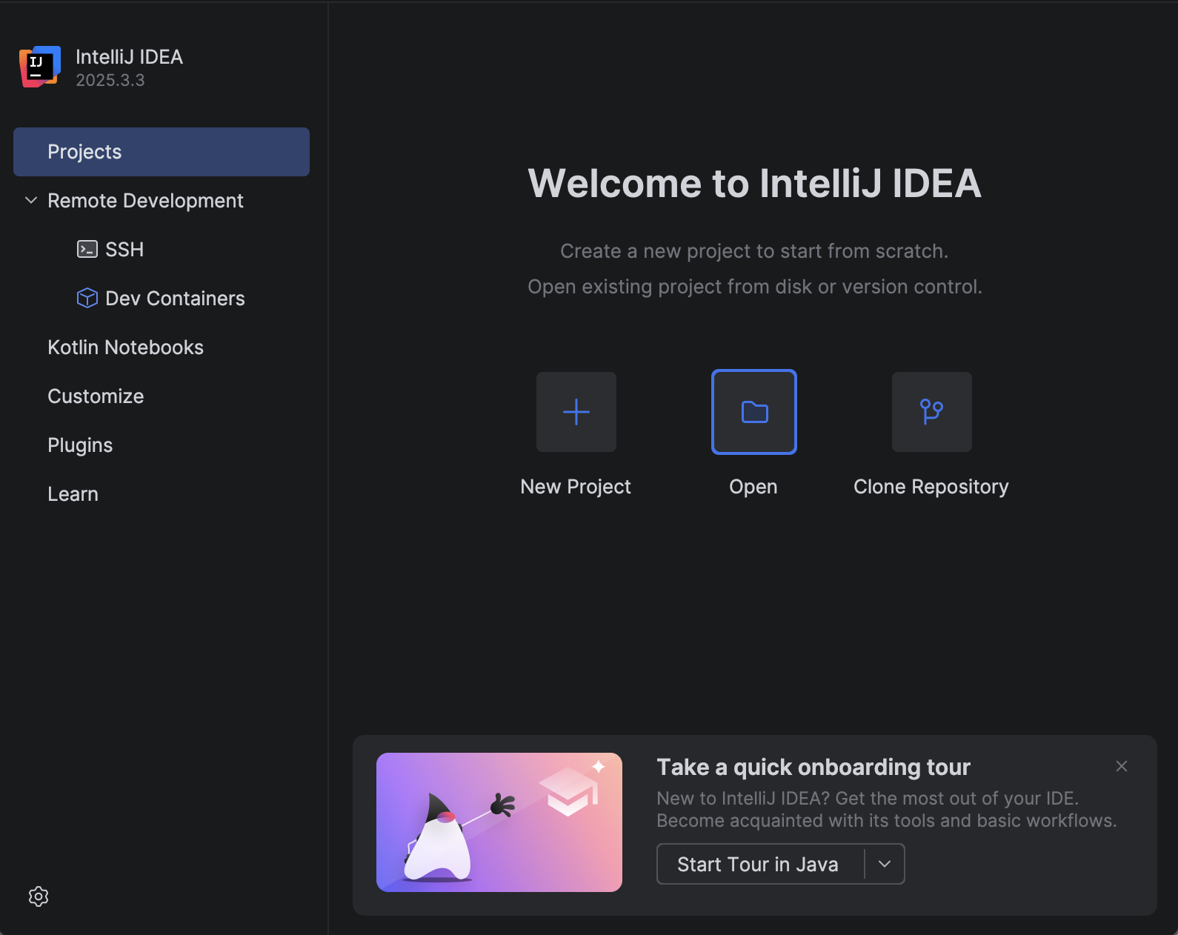
  - Or if the Intellij IDEA is already opened, go to File->New->Project from Existing Sources…
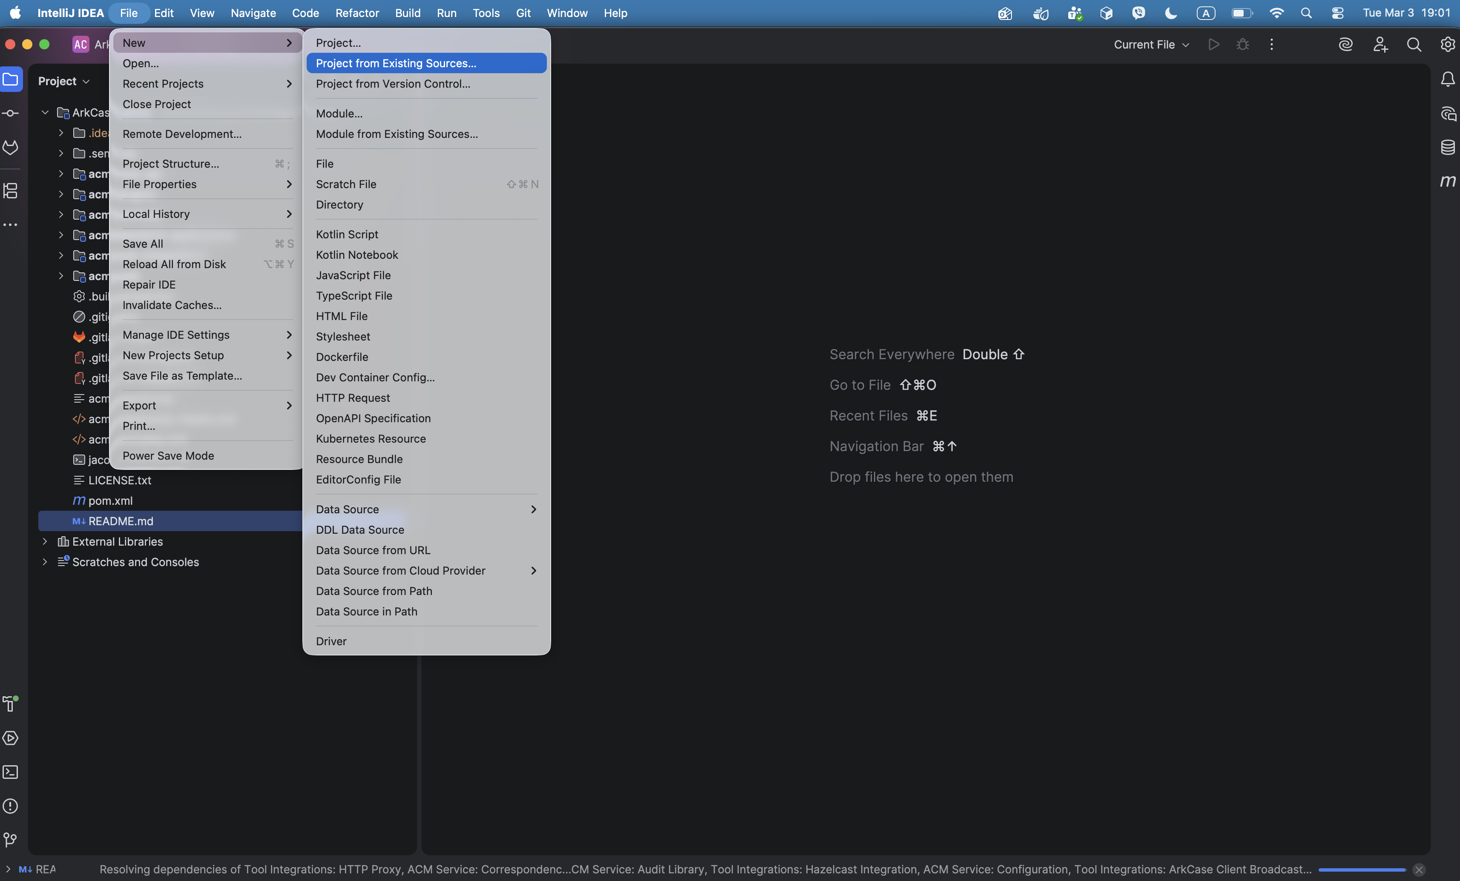
  - Select ArkCase project from the path {training.folder}/ArkCase
    - NOTE: wait while indexing and processes are in progress
  - Click Trust Project
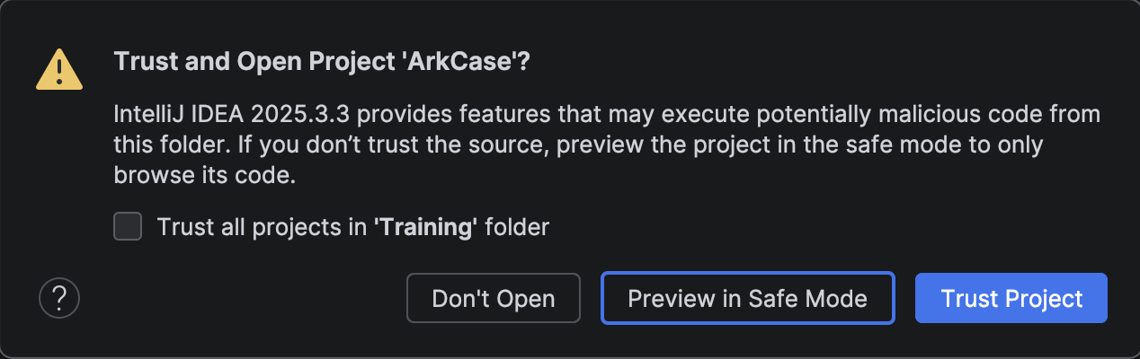
  - Create Local Tomcat configuration
    - Click Current File->Edit Configurations… button on top-right side
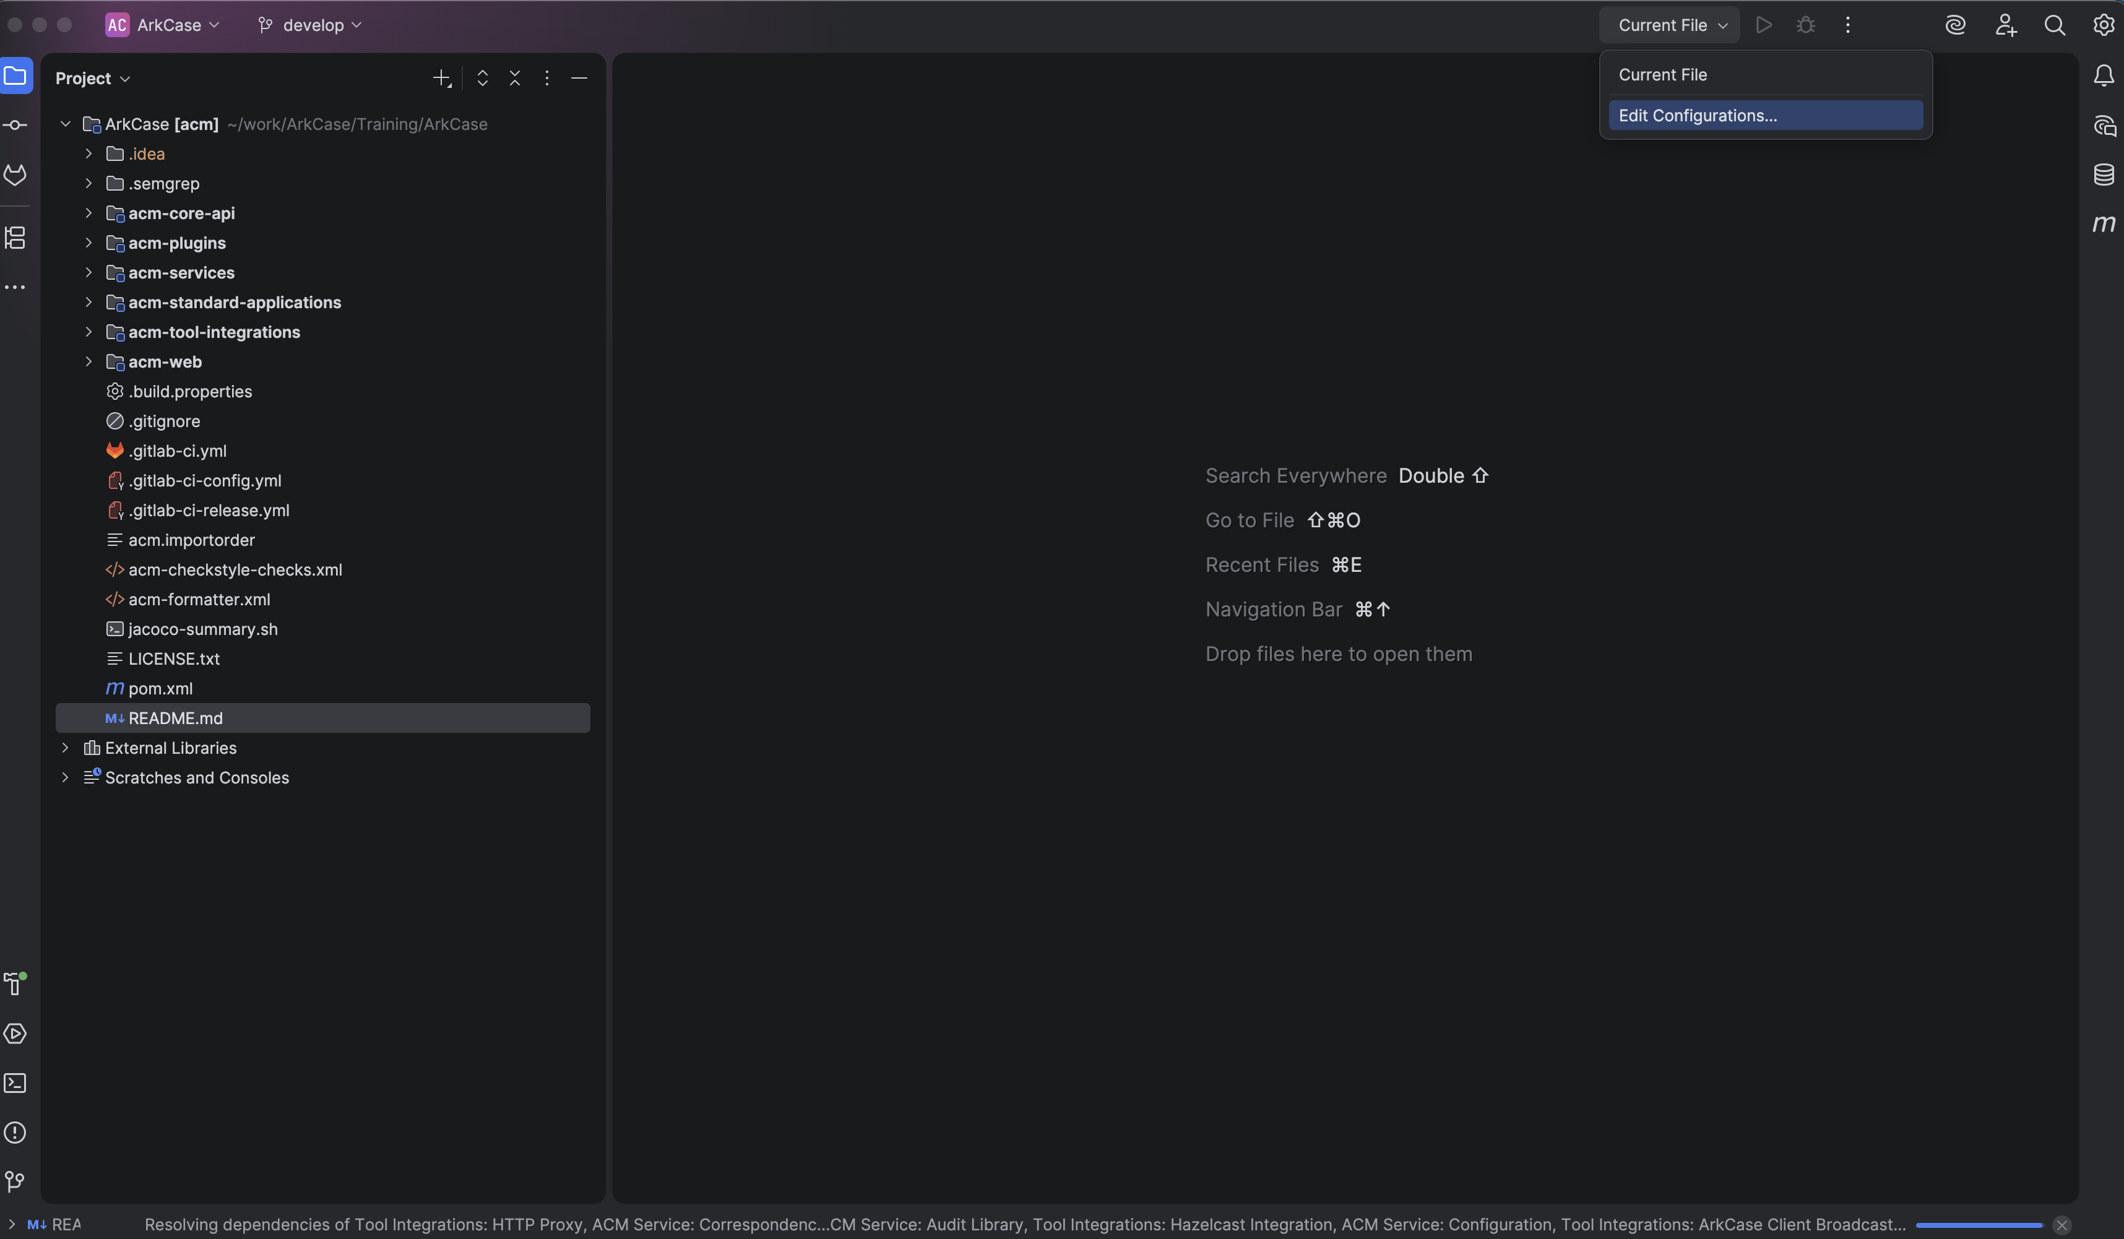
    - Click + sign, go to Tomcat Server, then Local
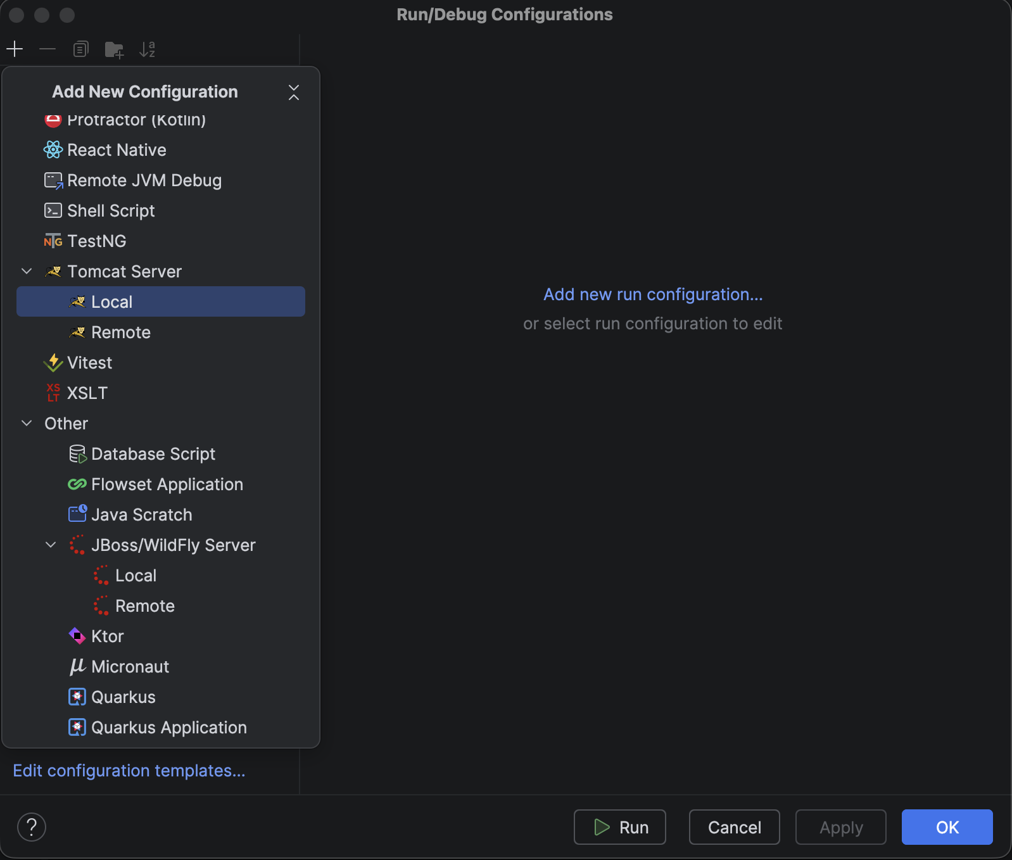
    - Server tab:
      - Name: ArkCase Core (or any name that you want)
      - Application Server
        - Click on Configure button
        - Select your Tomcat installation (select folder {training.folder}/apache-tomcat-9.0.117)
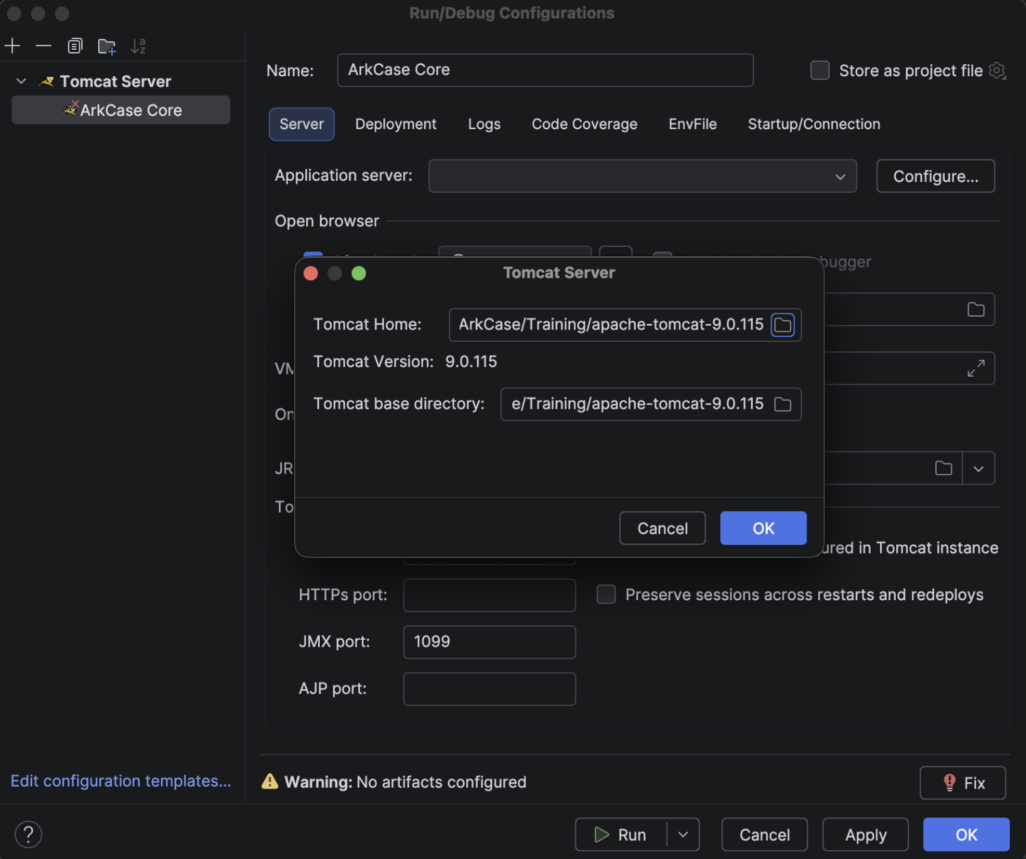
      - URL: https://acm-arkcase:8843/arkcase
      - VM Options:
-Djava.net.preferIPv4Stack=true
-Duser.timezone=GMT
-Djavax.net.ssl.trustStorePassword=password
-Djavax.net.ssl.trustStore={training.folder}/ArkCase_Docker_Services_Training/cert/arkcase.ts
-Dspring.profiles.active=ldap,custom,local
-Xms1024M
      - JRE 17
      - Ports:
        - HTTP: 8080
        - HTTPS: 8843
        - JMX: 1099
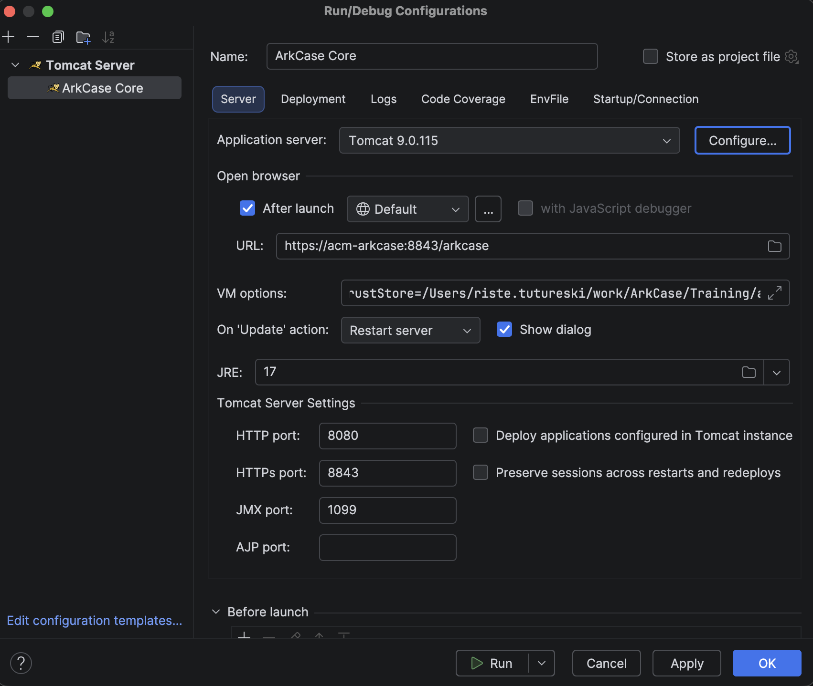
    - Deployment tab:
      - Click on the + sign
      - Click Artifacts…
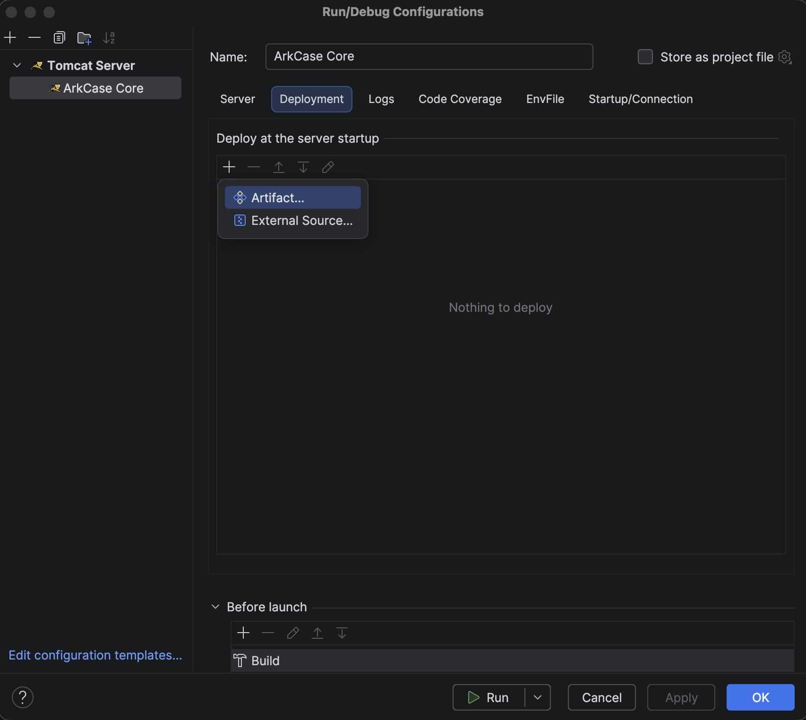
        - If you are not seeing Artifacts…, go View->Tool Windows->Maven
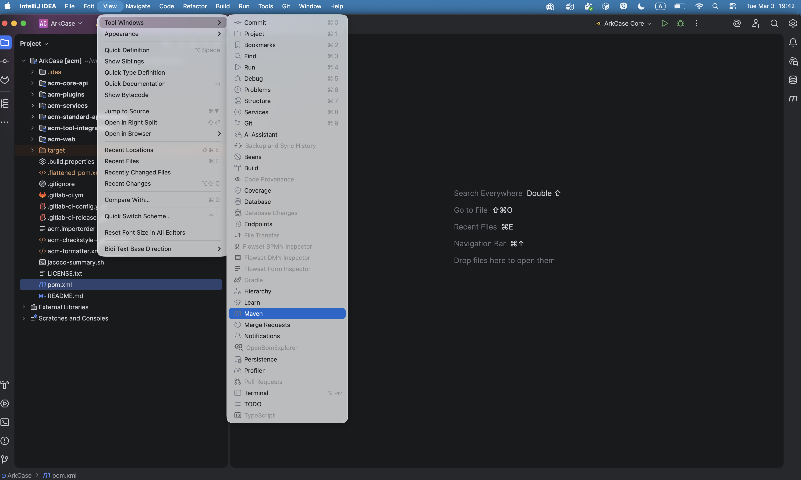
        - And then click Reload all Maven Projects
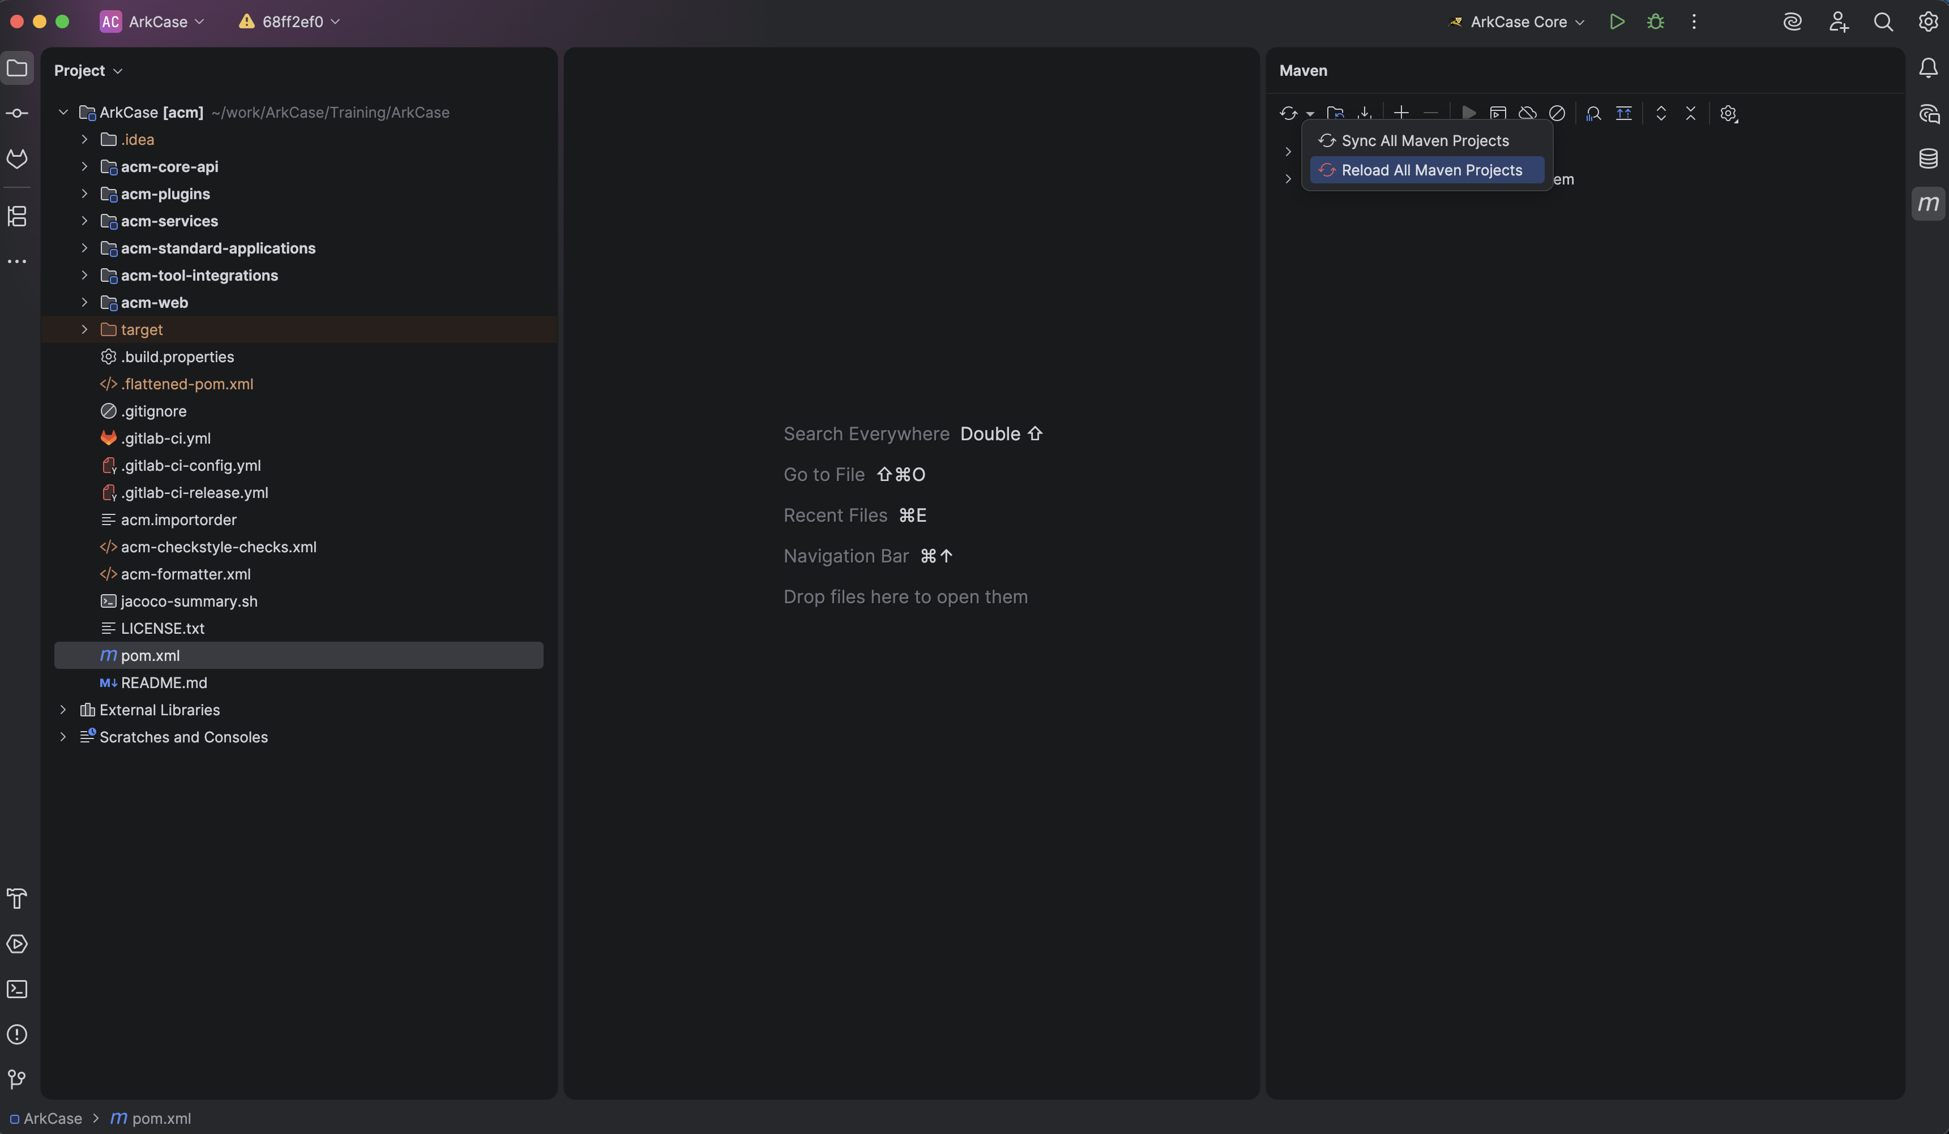
      - Select arkcase:war exploded
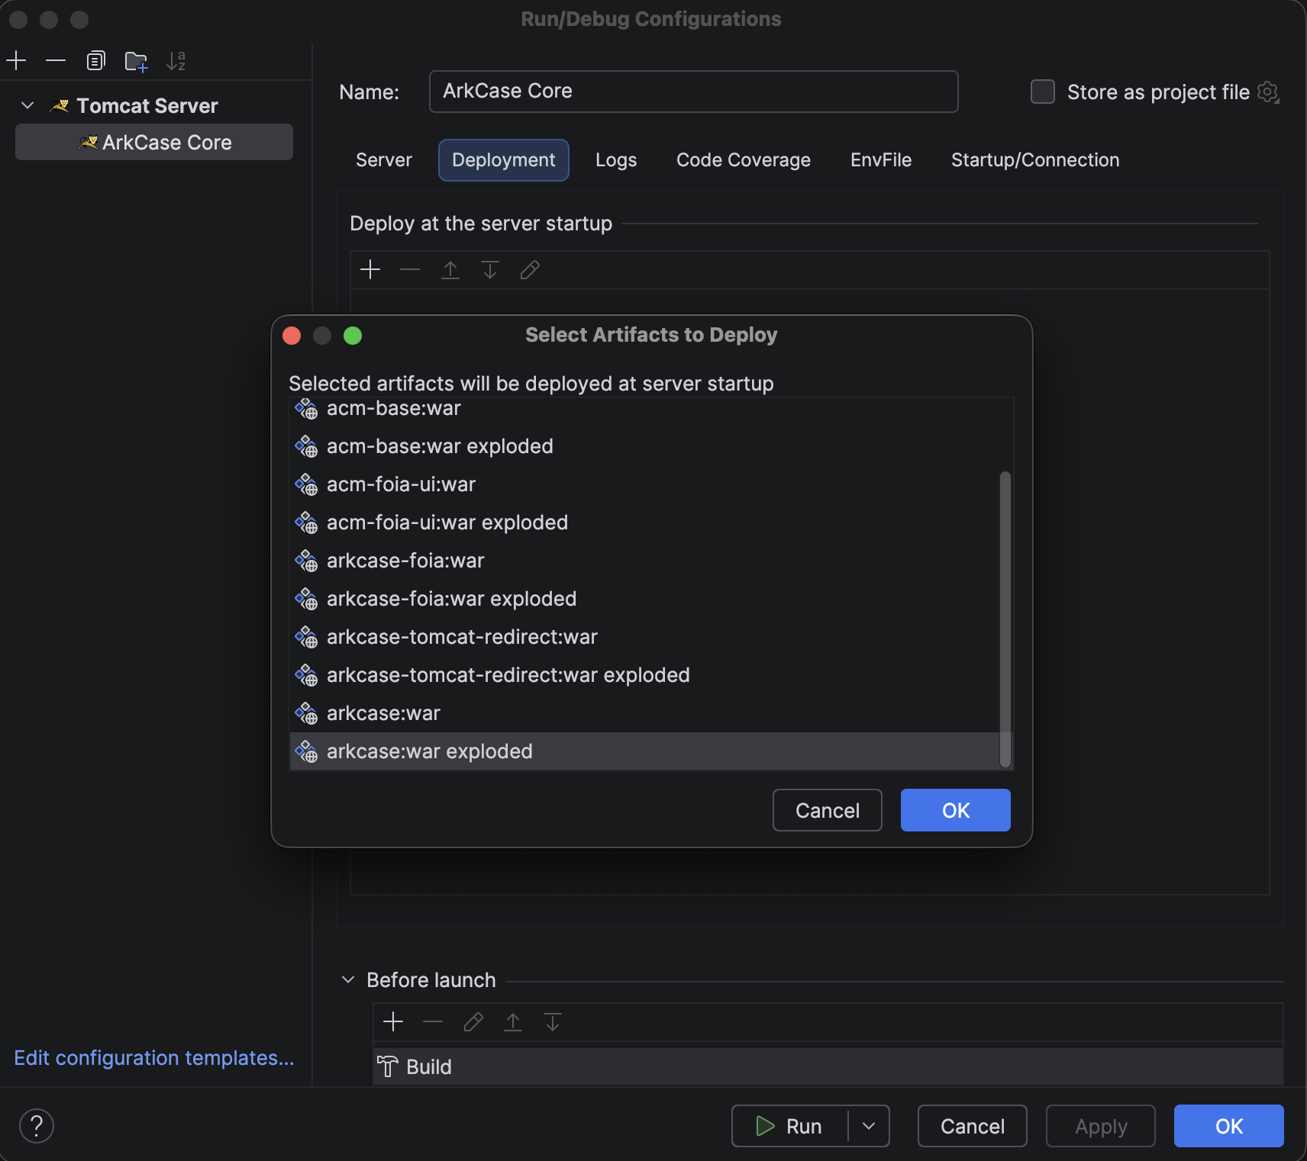
      - Application Context: /arkcase
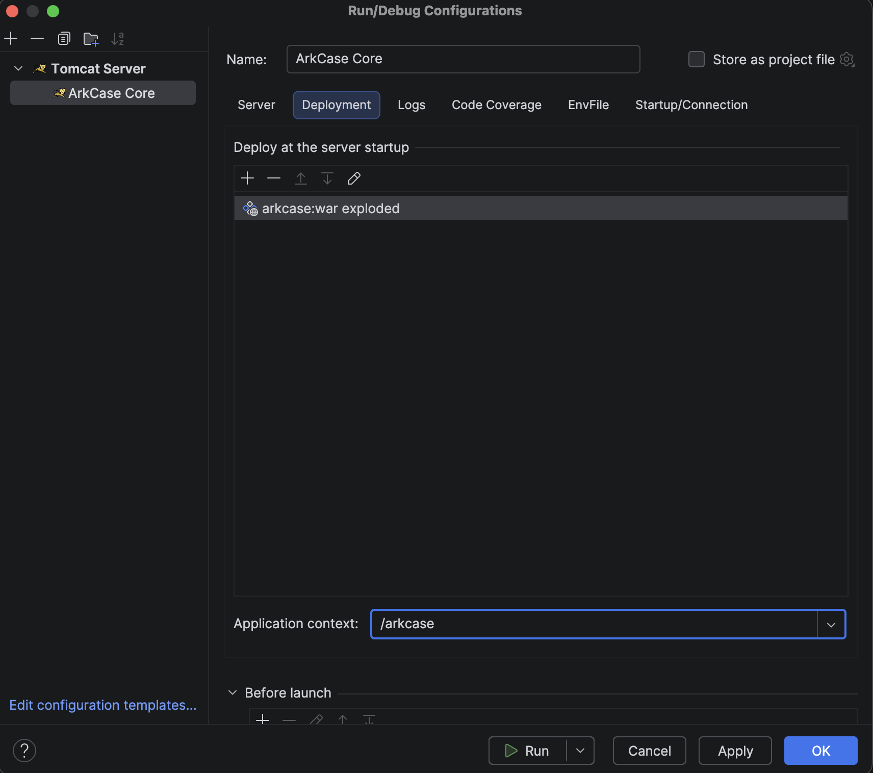

  - Install EnvFile plugin
    - Go Settings->Plugins->(Search Box) EnvFile
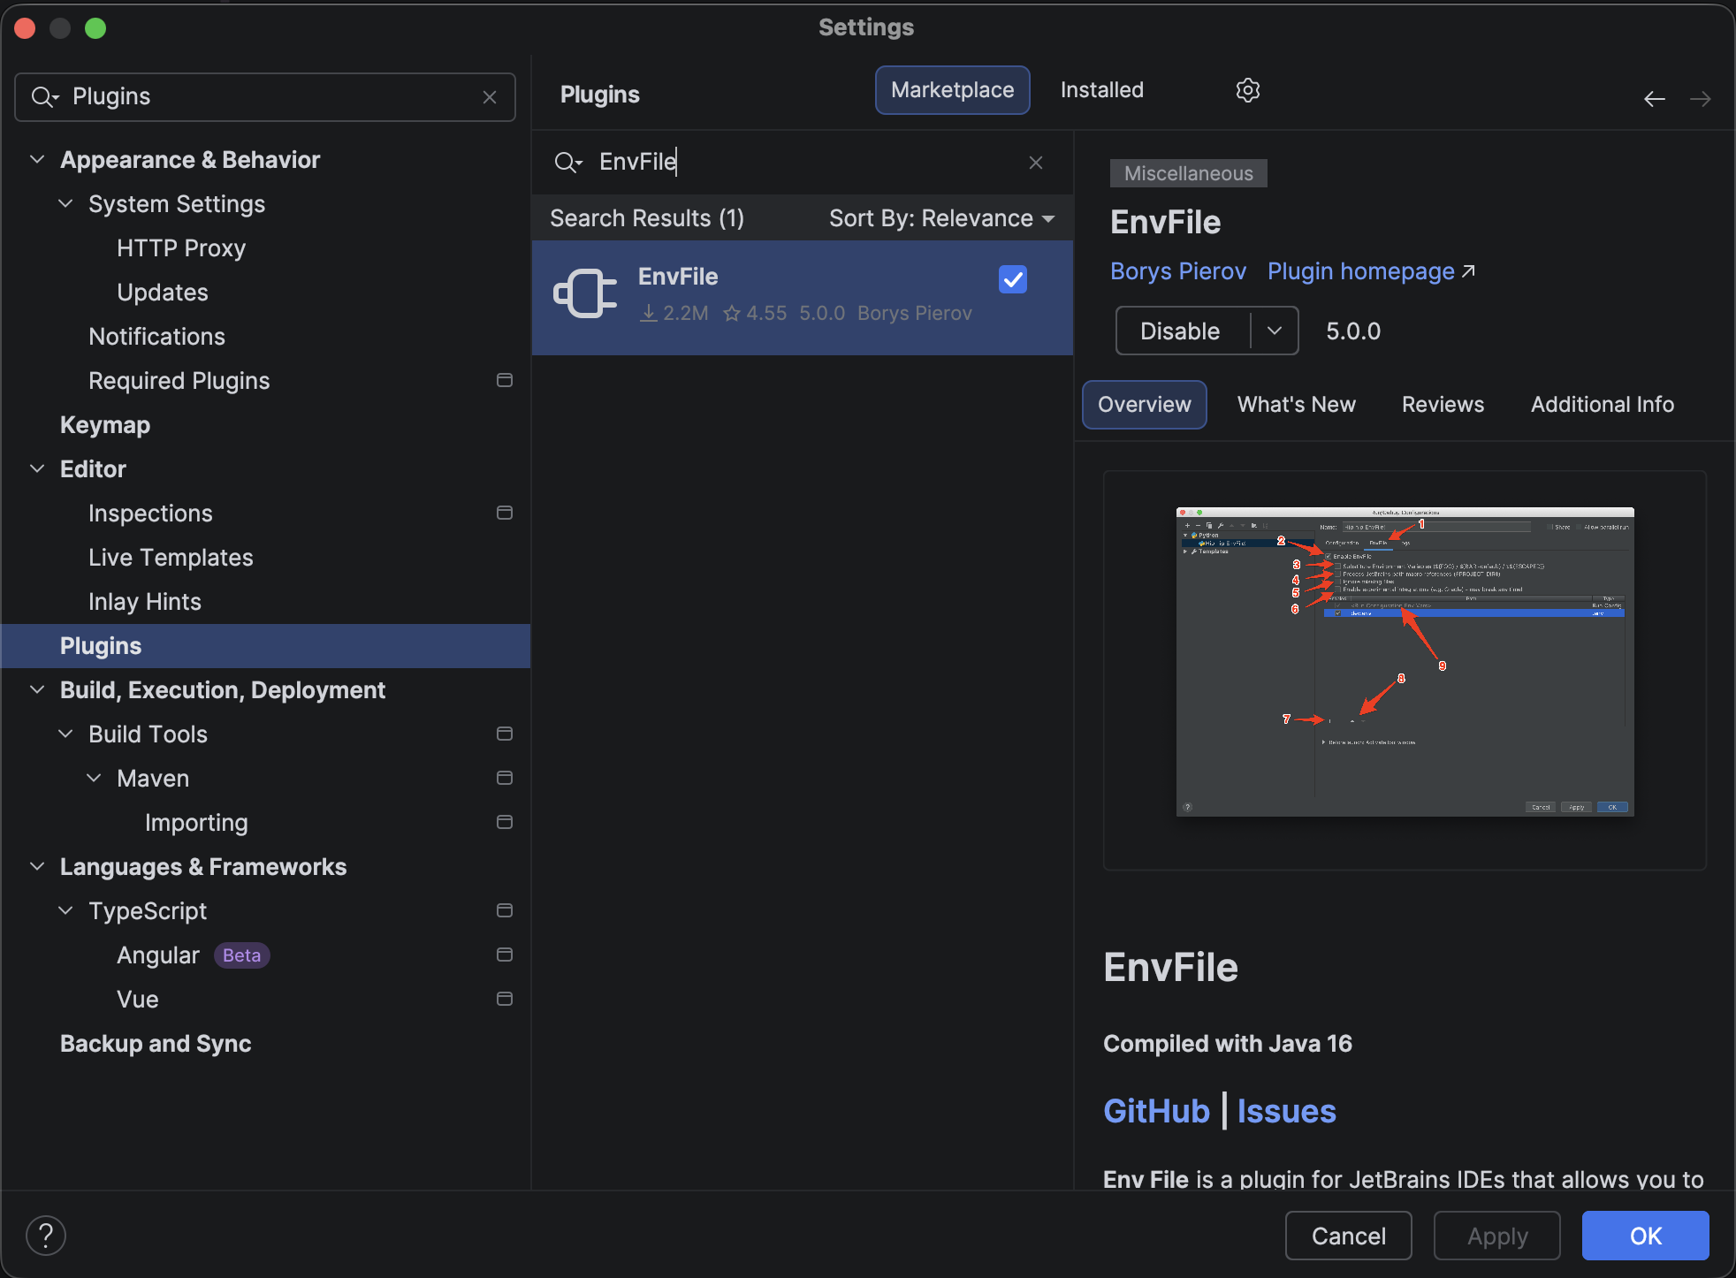
  - Configure EnvFile tab
    - Go to previously Tomcat Local configuration on Intellij IDEA: ArkCase Core->Edit Configuration->(Tab)EnvFile
    - Select Enable EnvFile
    - Click on + sign
    - Add… .env File
    - Select file {training.folder}/ArkCase_Docker_Services_Training/env/.env-core
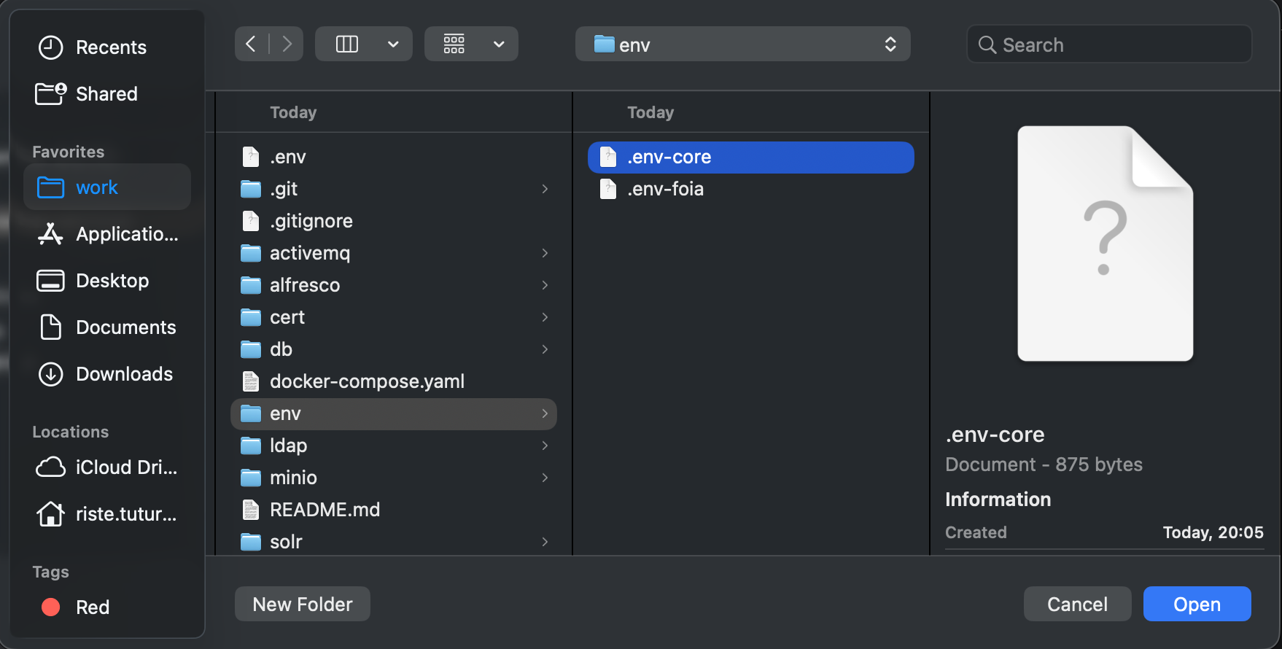
    - (MAC ONLY) If you are not seeing the file inside, while you are on that window, press Command+Shift+. (Command+Shift+<DOT>)
    - (UBUNTU ONLY) If you are not seeing the file inside, right click on the folder env and click Show Hidden Files and Directories
  - Enable annotation processing (we will need for Lombok)
    - Go to Settings->Build, Execution, Deployment->Compiler->Annotation Processors
      - Select: Enable annotation processing
      - Select: Obtain processors from project classpath
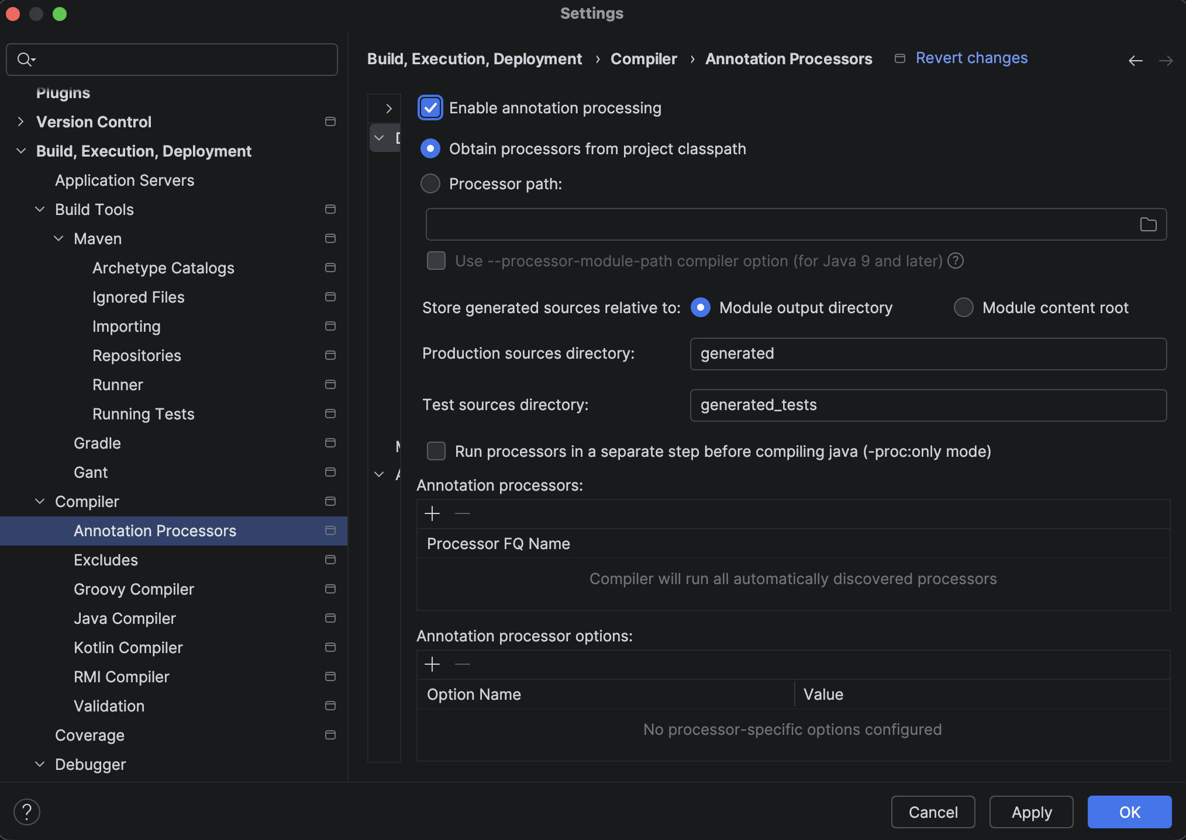
  - Install Lombok plugin
    - Settings->Plugins->(Search Box)Lombok
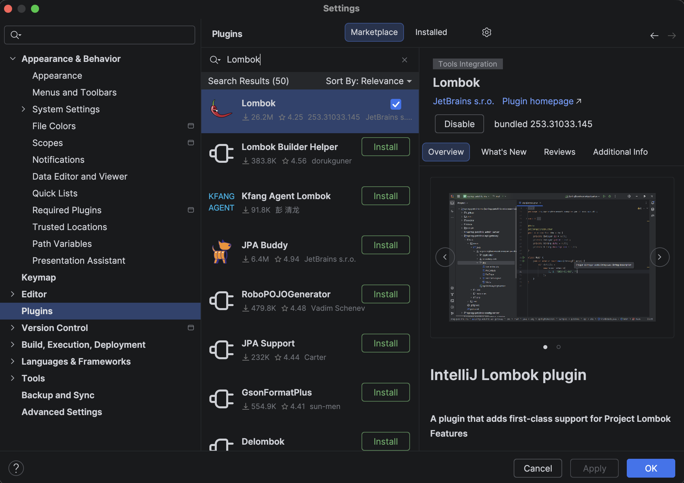
  - Ensure correct Java 17 is used cross entire Intellij IDEA
    - File->Project Structure->Project->SDK
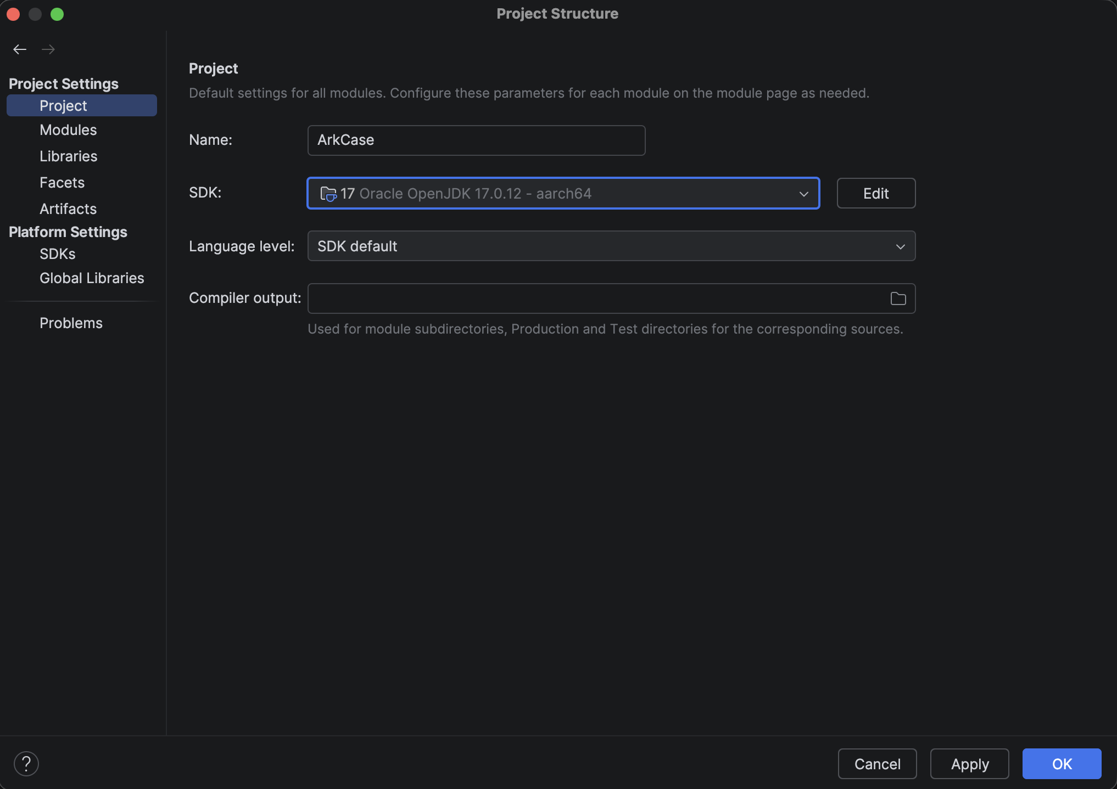
    - File->Project Structure->Modules
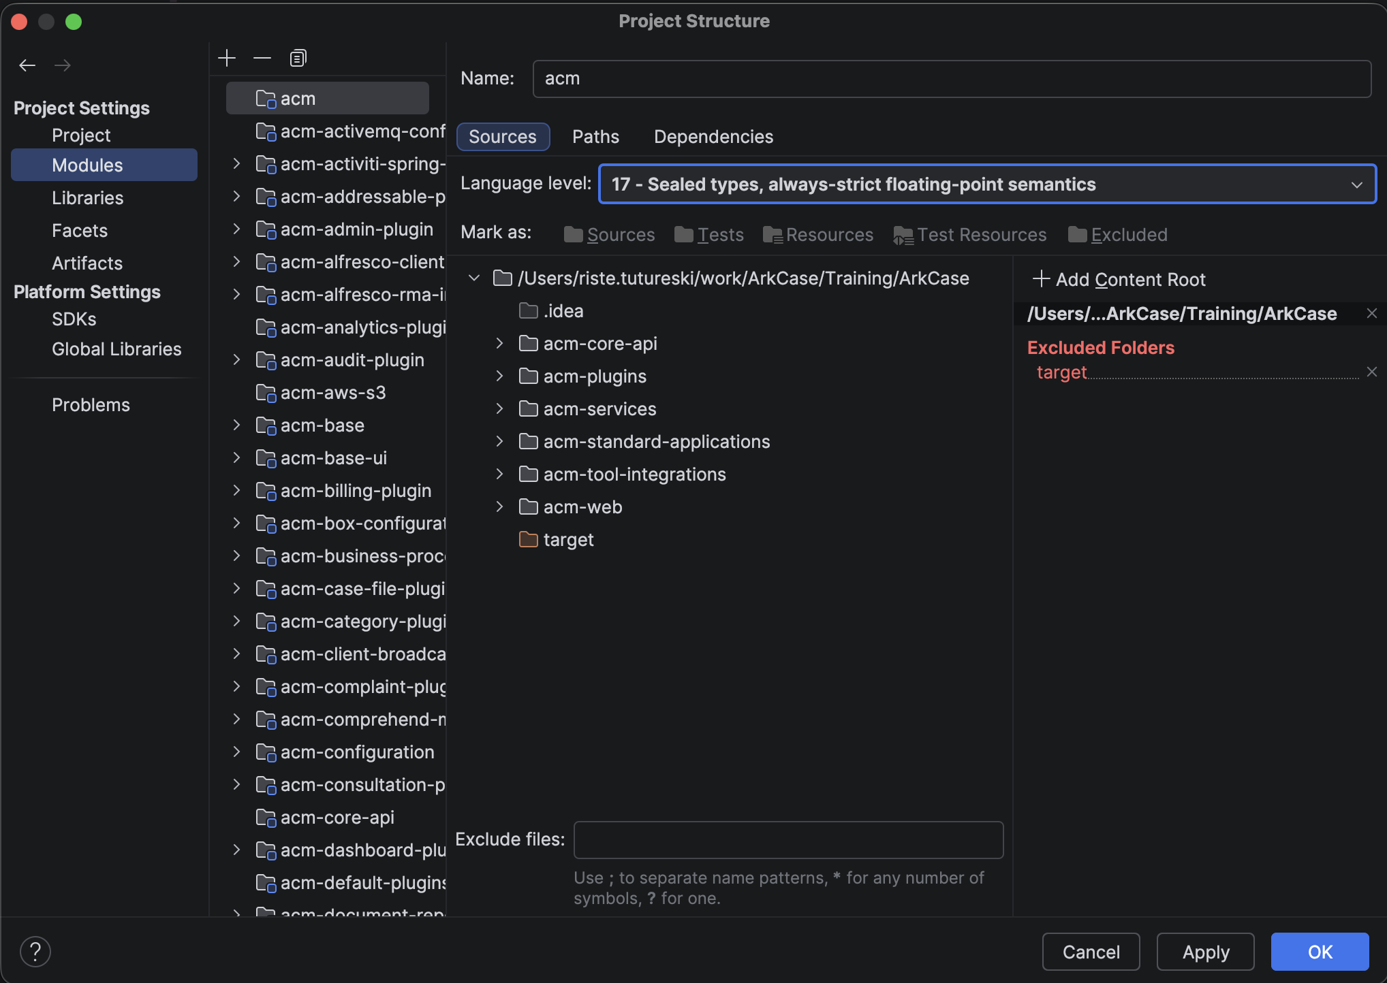
    - File->Project Structure->SDKs
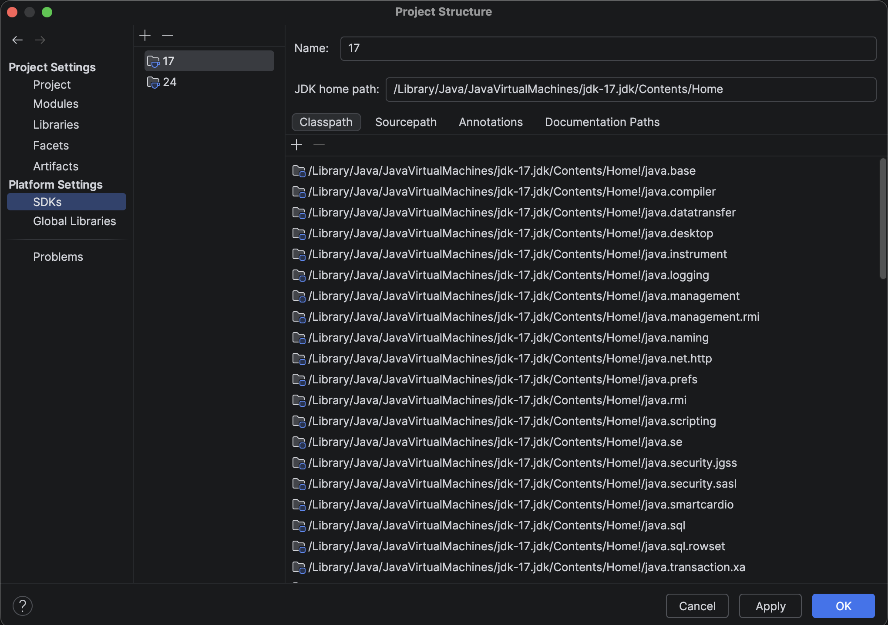
  - Sync project for every change
    - Go to Settings->Build, Execution, Deployment->Build Tools
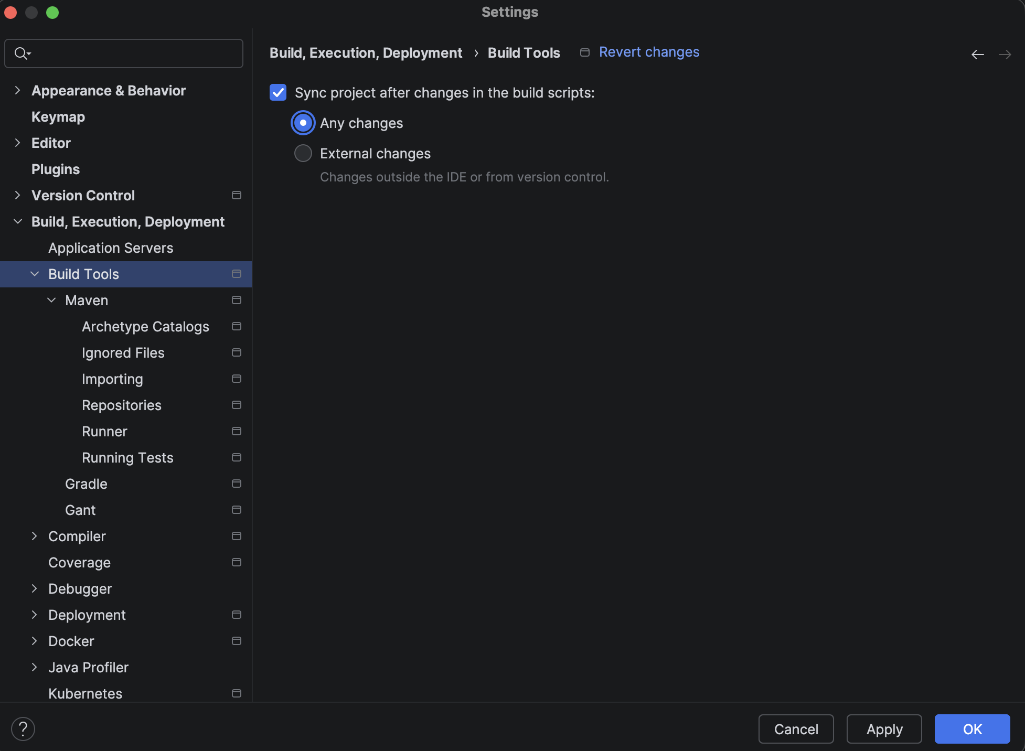
  - Do not group imports from the same package
    - Go to Settings->Editor->Code Style->Java->(Tab)Imports
      - Set Class count to use import with ‘*’: 999
      - Set Names count to use static import with ‘*’: 999
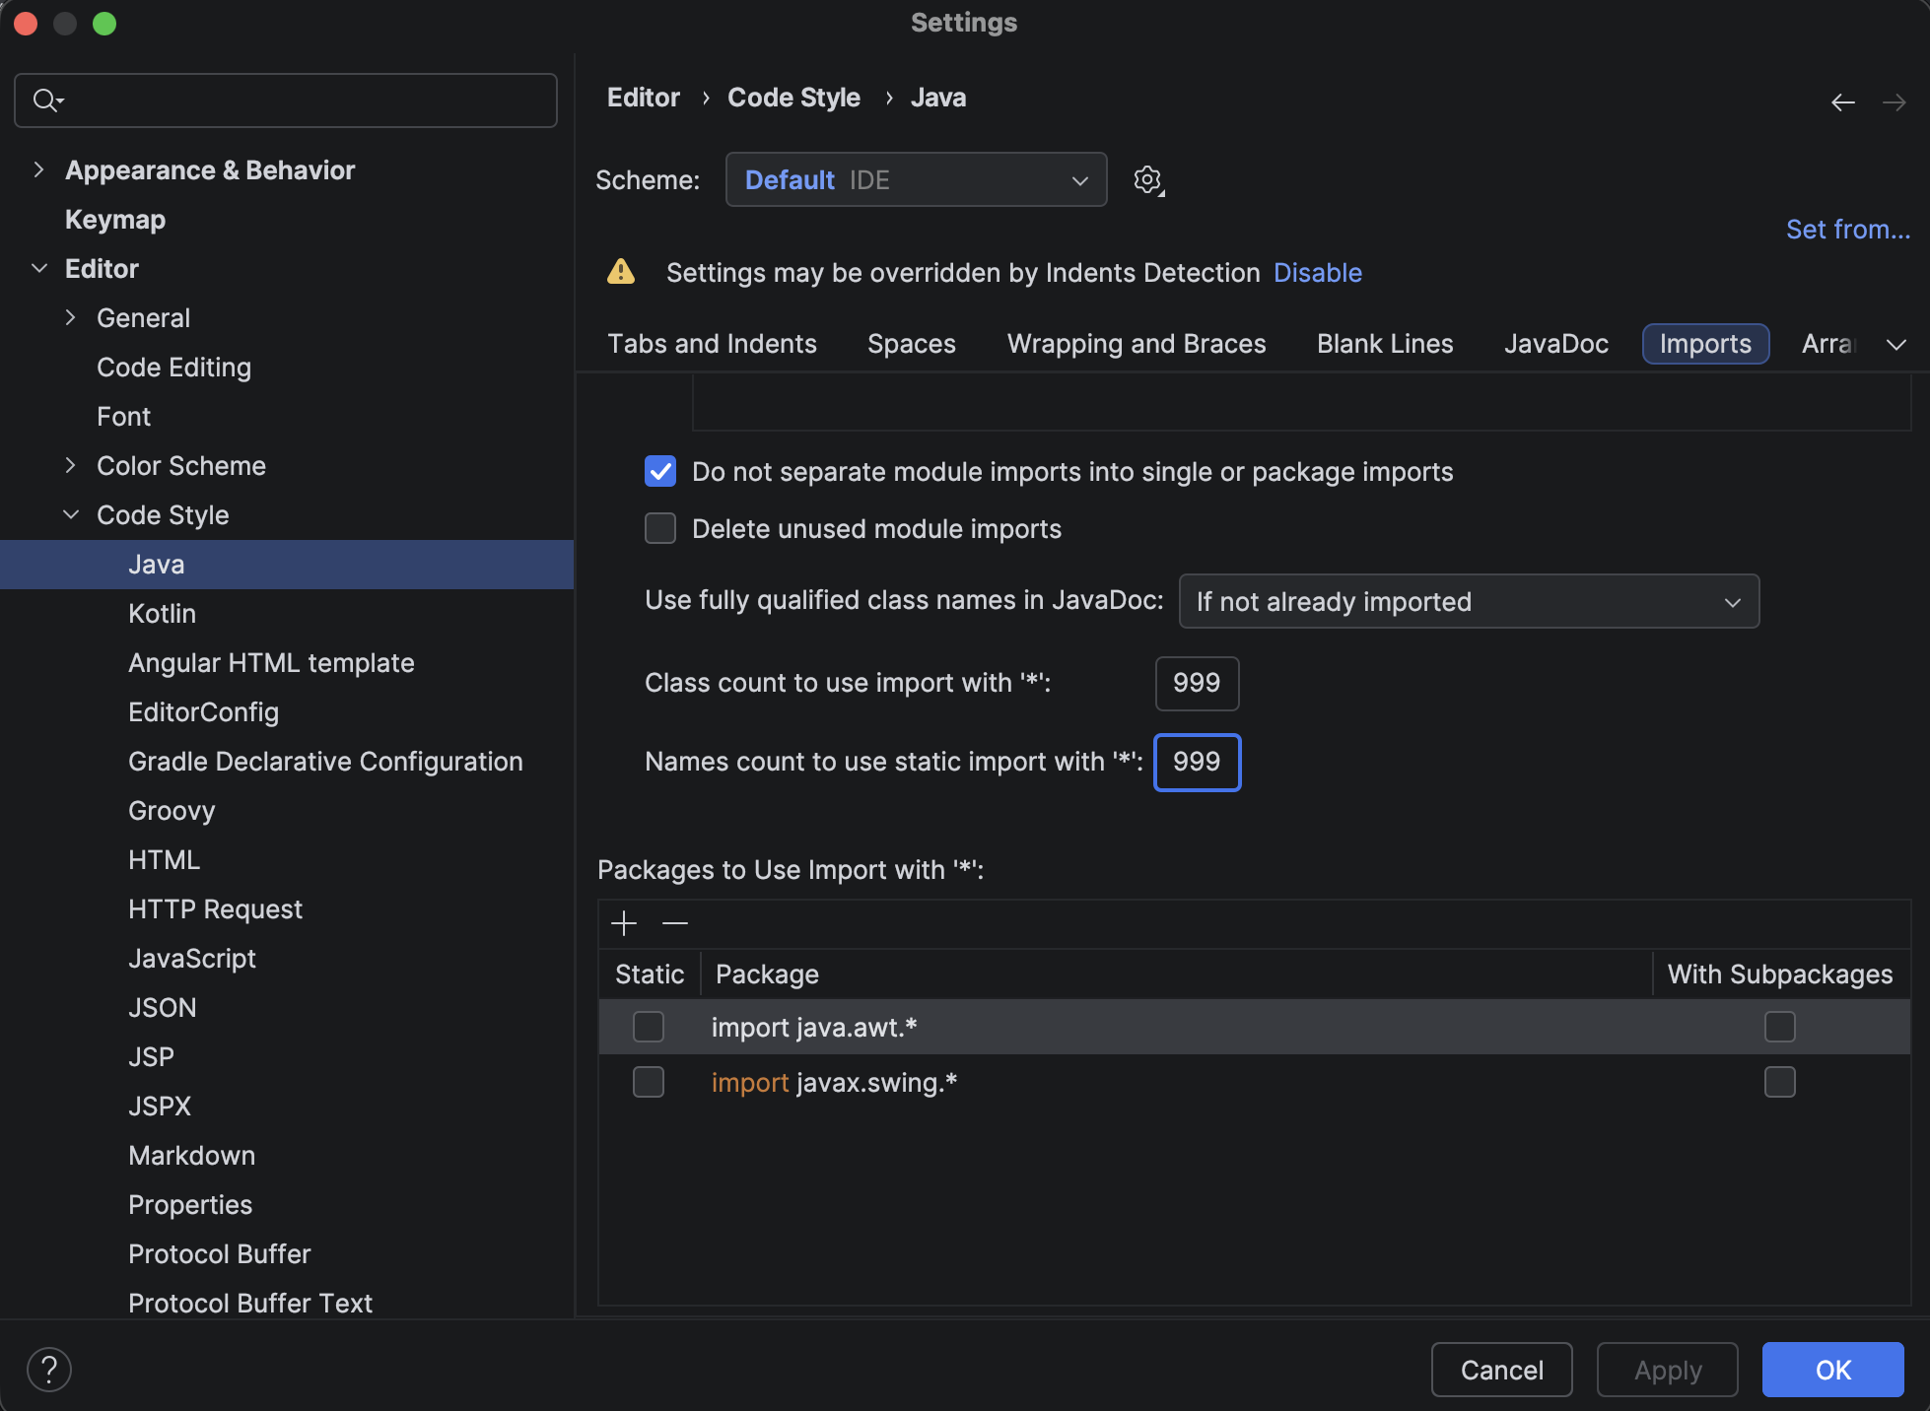
  - (ONLY FOR THIS TRAINING) Copy Runtime File
    - Go to previously Tomcat Local configuration: ArkCase Core->Edit Configuration->Before launch->(Click + sign)->Run External Tool->(Click + sign)
      - Name: Copy Runtime File
      - Program:
        - Mac: /bin/zsh
        - Ubuntu: /bin/bash
      - Arguments: -lc "cp -f '{training.folder}/ArkCase_Docker_Services_Training/minio/arkcase-config/arkcase-runtime.yaml' '{training.folder}/ArkCase_Training/acm-standard-applications/war/arkcase/target/arkcase-25.09.01-SNAPSHOT/WEB-INF/classes/acm/acm-config-server-repo'"
      - Working Directory: $ProjectFileDir$
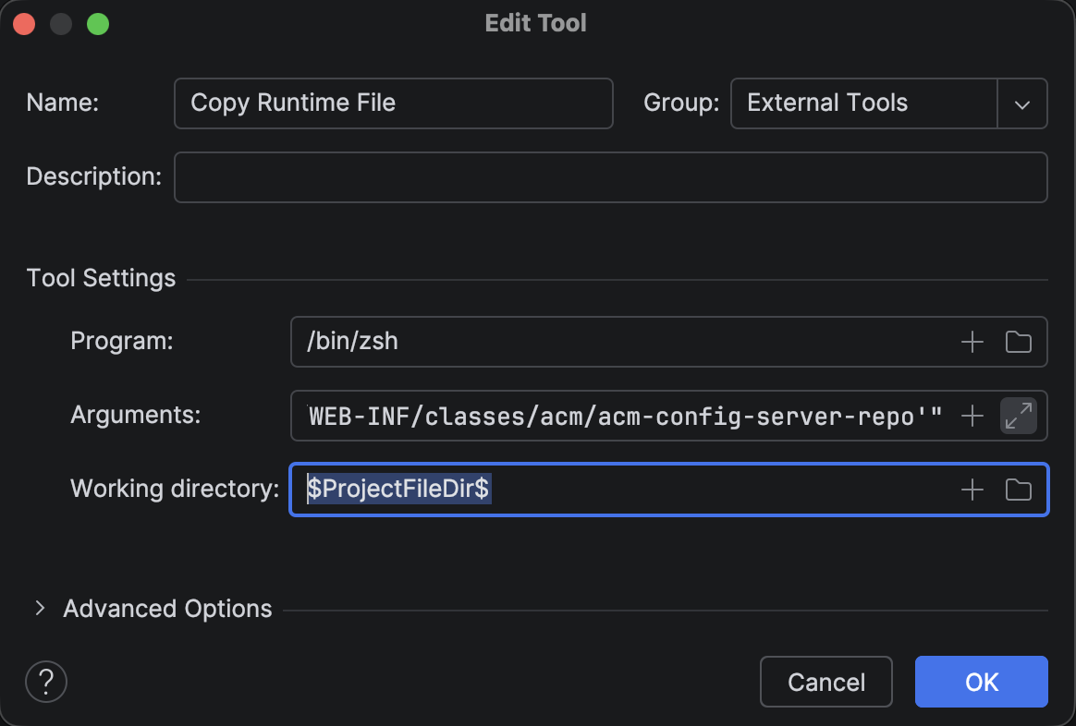
      - Make sure that is first in the list of Before launch
  - Create the following folder structure:
    - {home.folder}/.arkcase/custom
  - Press Start Button
    - Be sure that Docker Compose is up
    - After start, the admin user is:
      - Username: arkcase-admin@arkcase.org
      - Password: arkcase
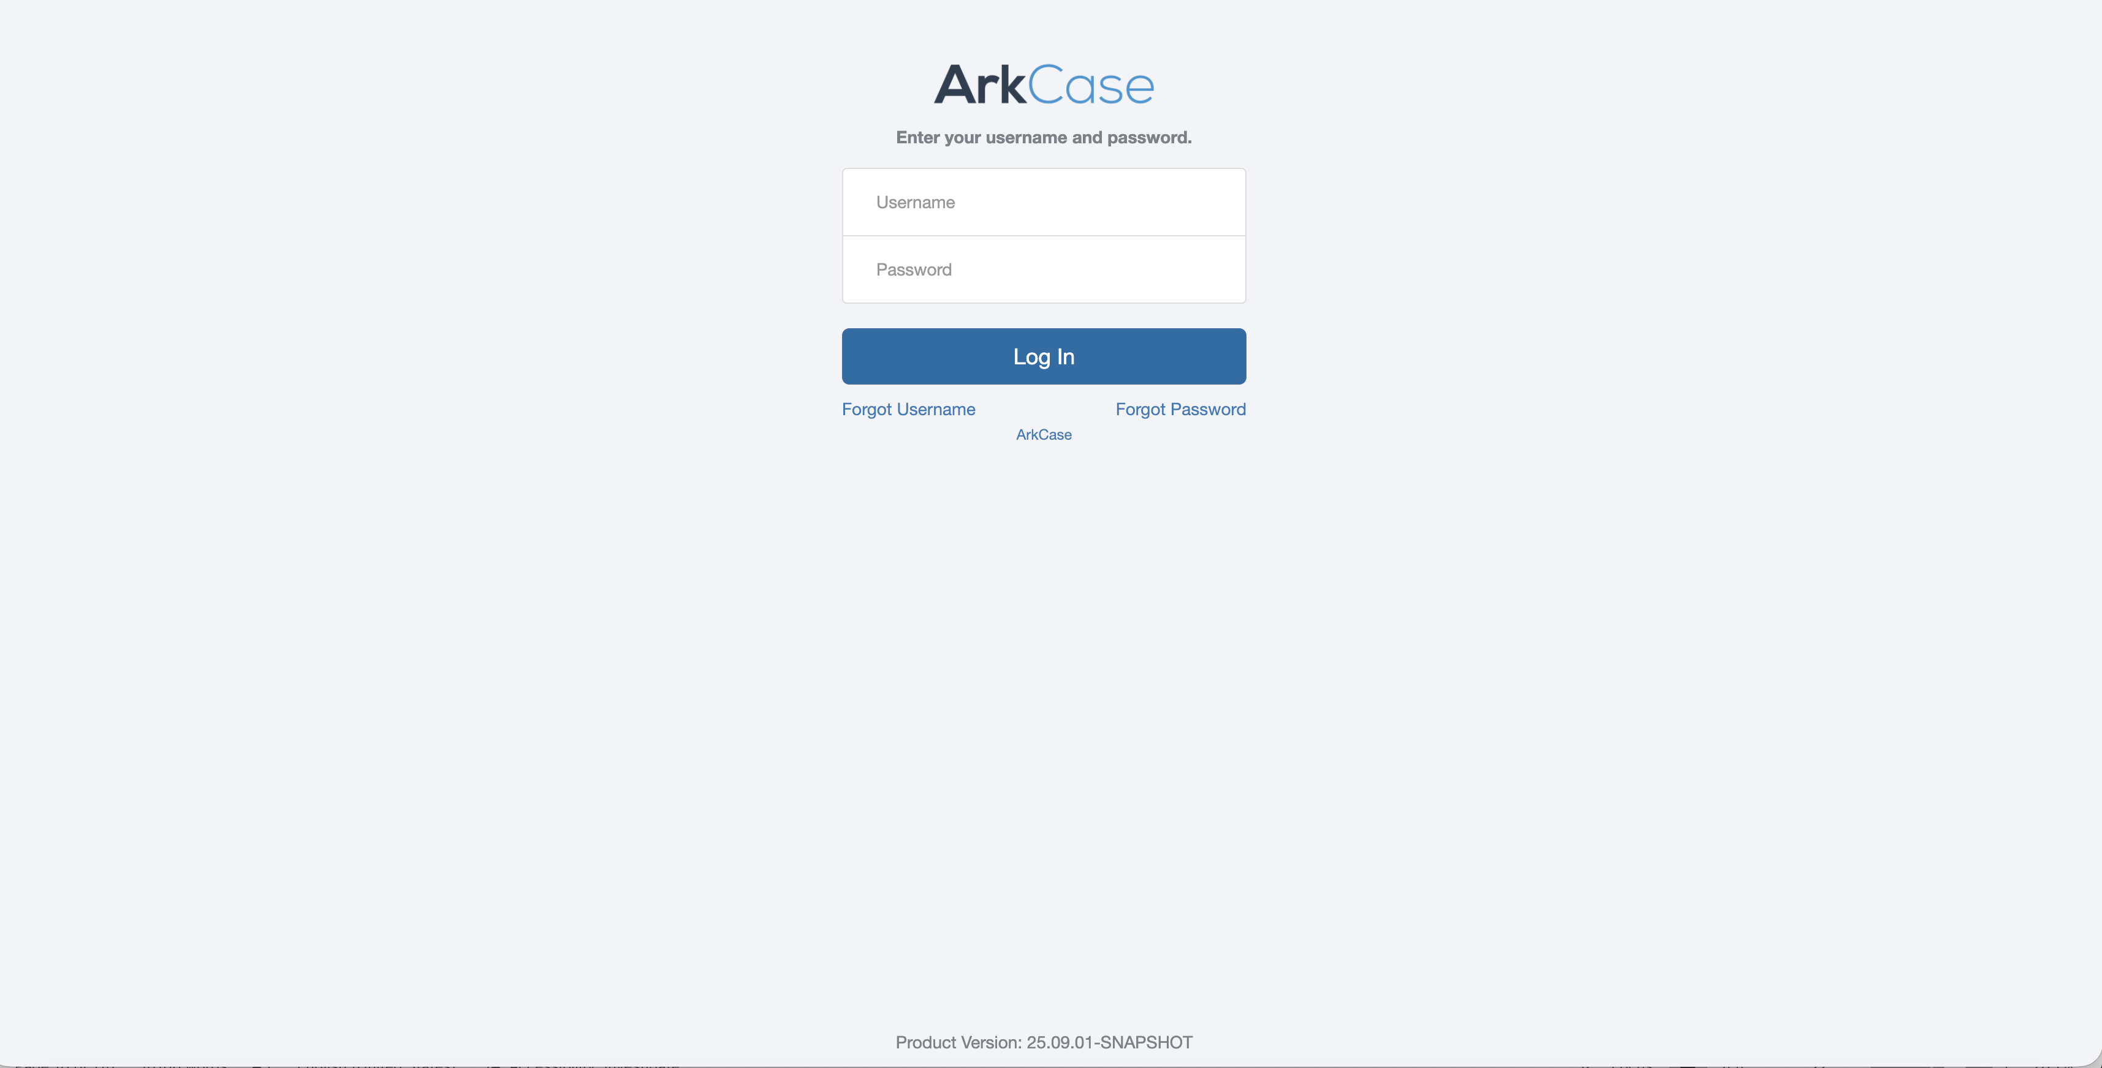

Extensibility

Extend Complaint Module

Overview

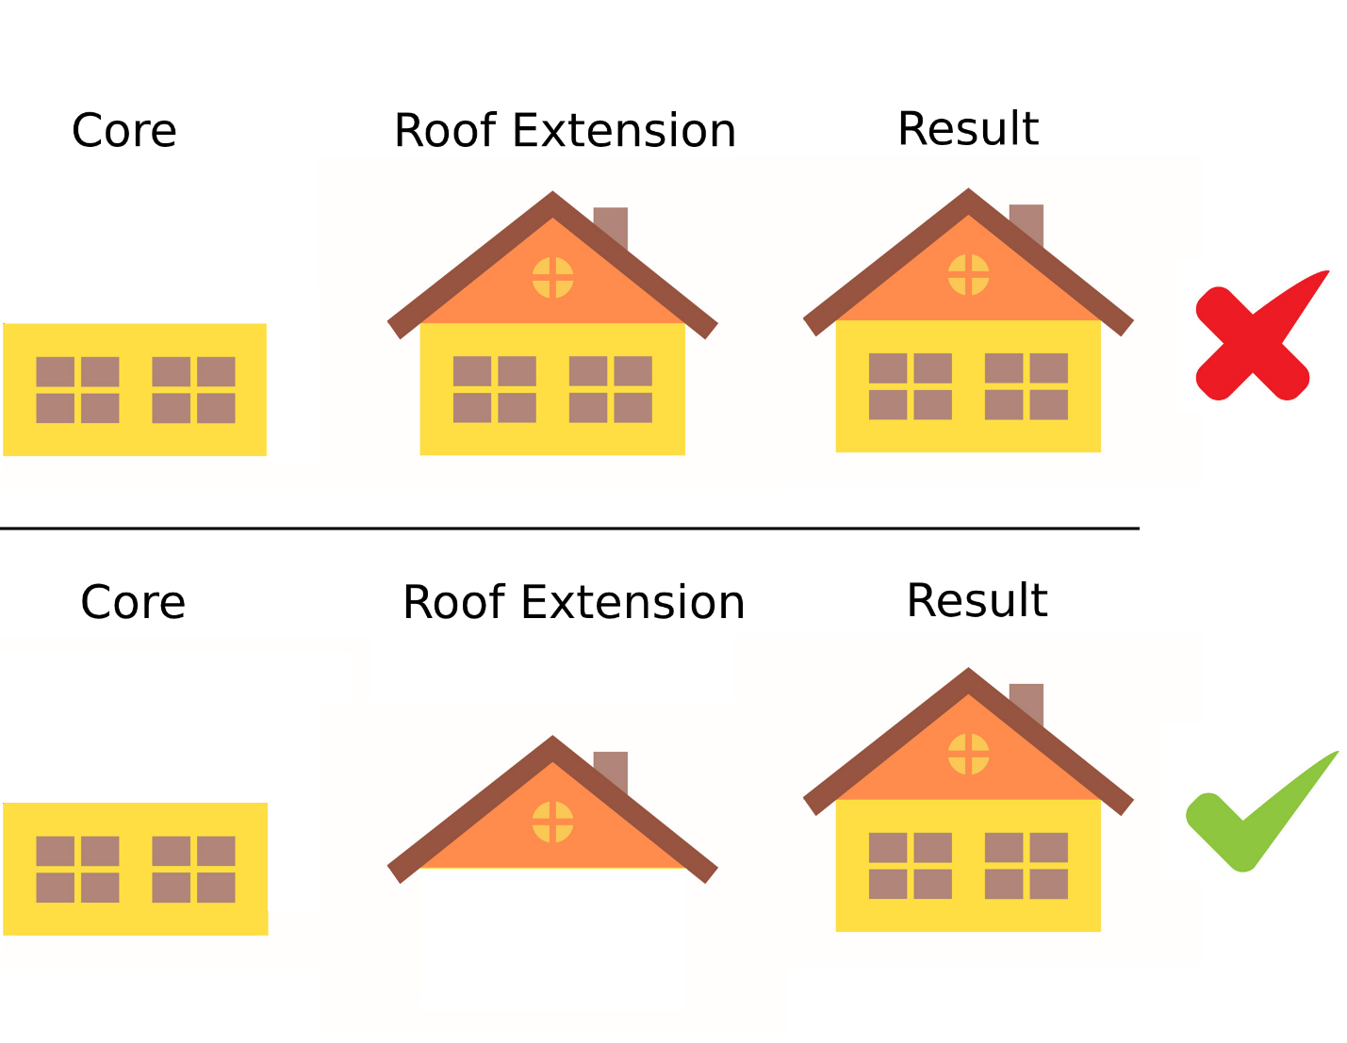
ArkCase Extensibility is methodology where you can add/modify/extend classes, modules, UI, database, etc … without changing the core ArkCase functionality.
ArkCase Extension is using ArkCase Core libraries for development.

Create Extension project
- Copy extension-template from the training documentation to your training folder
- Rename extension-template to complaint-extension
- Open Intellij IDEA
- Go File->New->Project From Existing Sources…
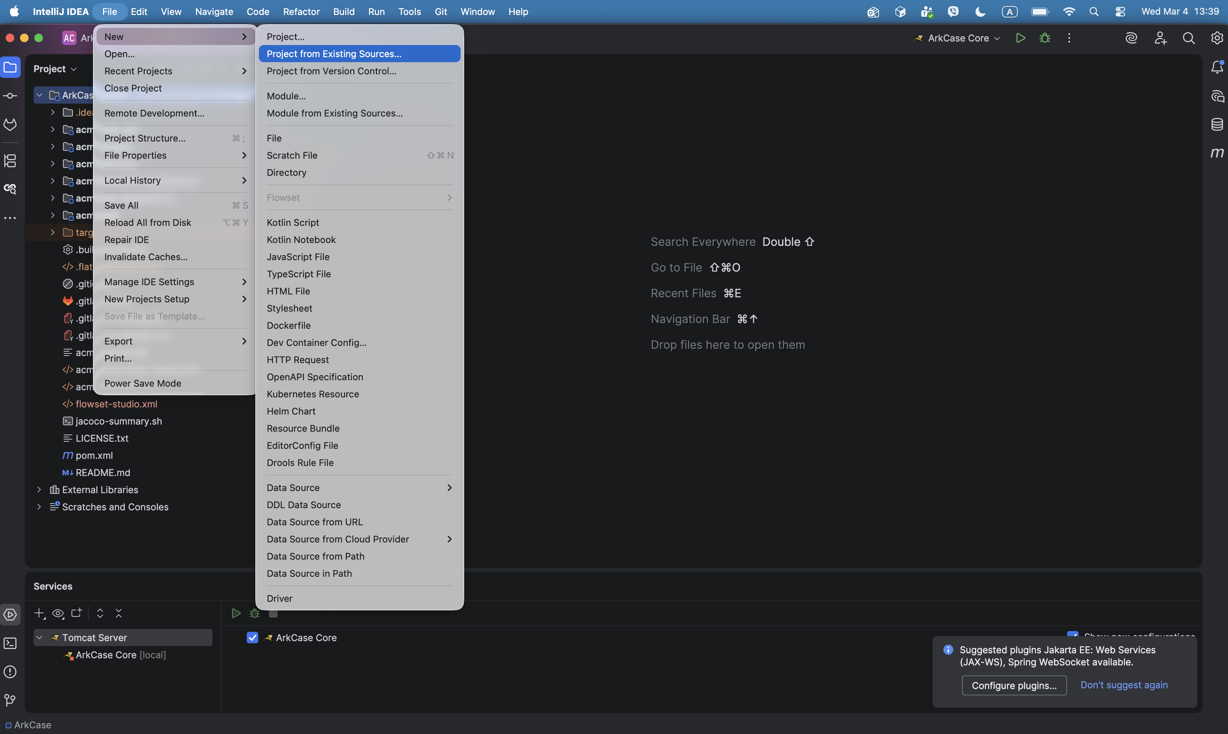
- Navigate and select the complaint-extension project and click OK
- Select Import project from external model, select Maven from the list, and click Finish
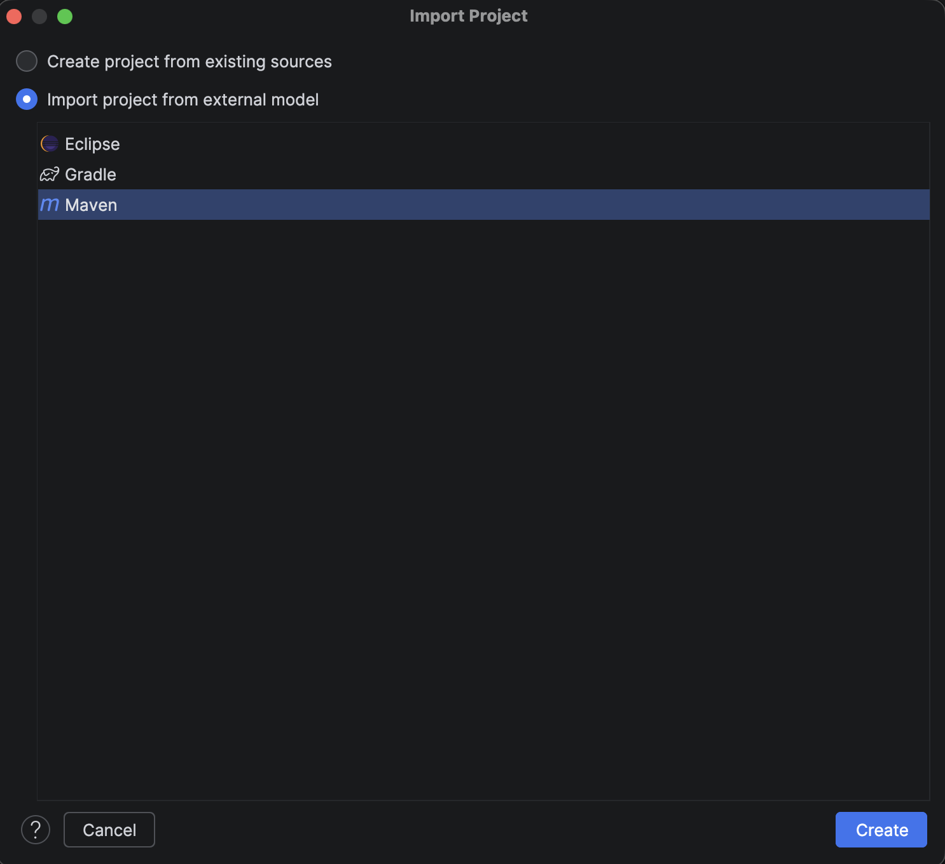
- Select New Window from the next popup
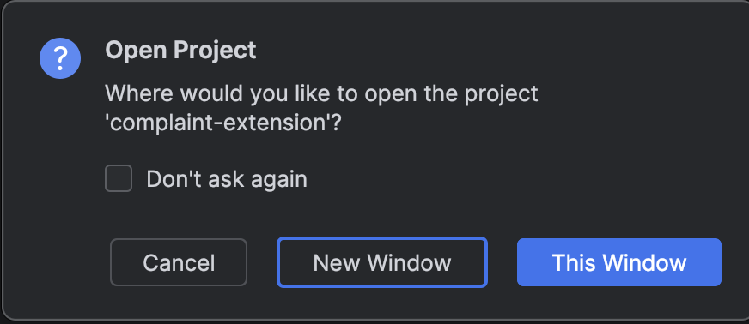
- Select Trust Project
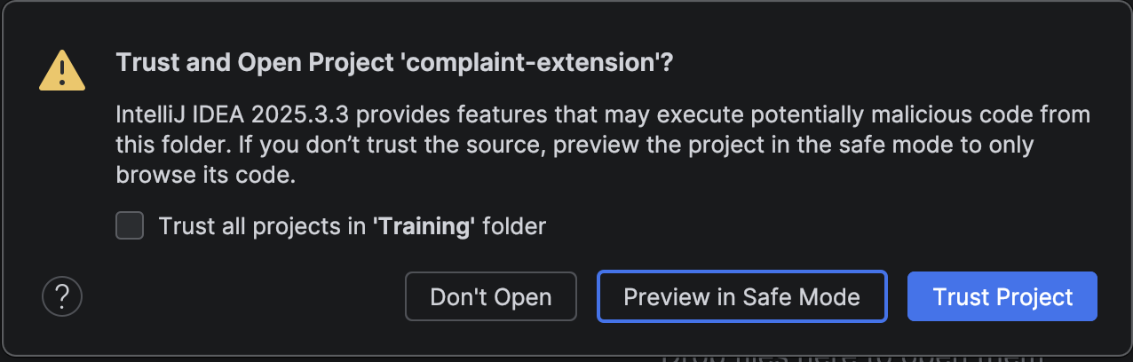
- Wait while the project is not fully loaded

Extend Complaint.java Class

In this session, we will focus on extending one of the existing core entities - Complaint. We are going to add subtitle field to core Complaint entity. Since we want to extend the Complaint module, first we need to add the dependency in the extension project for Complaint module.

- Open pom.xml file in the extension module in the complaint-extension project:
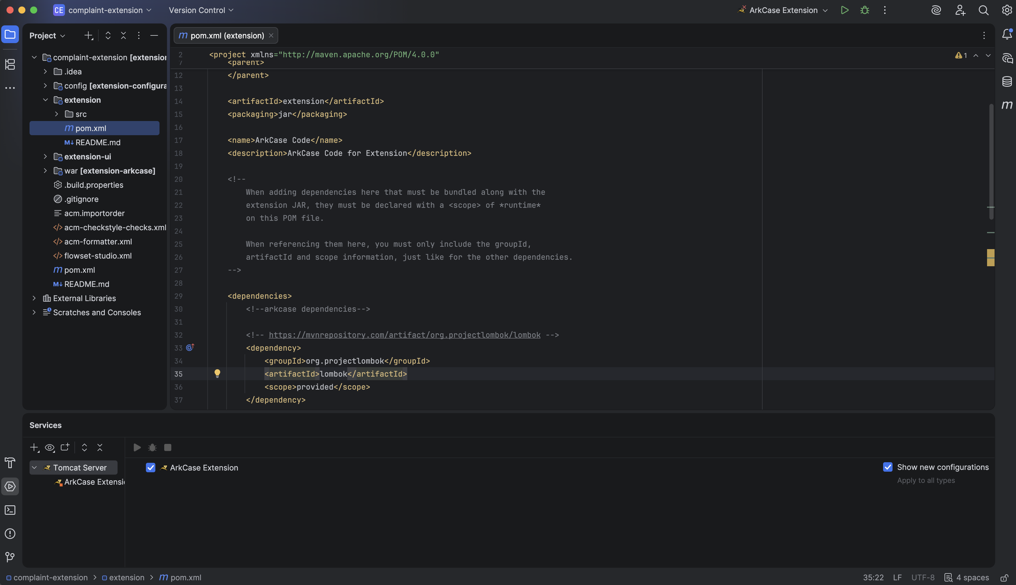
- Add this ArkCase dependency:
<dependency>
<groupId>com.armedia.acm.acm-plugins.acm-default-plugins</groupId>
<artifactId>acm-complaint-plugin</artifactId>
<version>${arkcase.version}</version>
</dependency>

- It should look like this
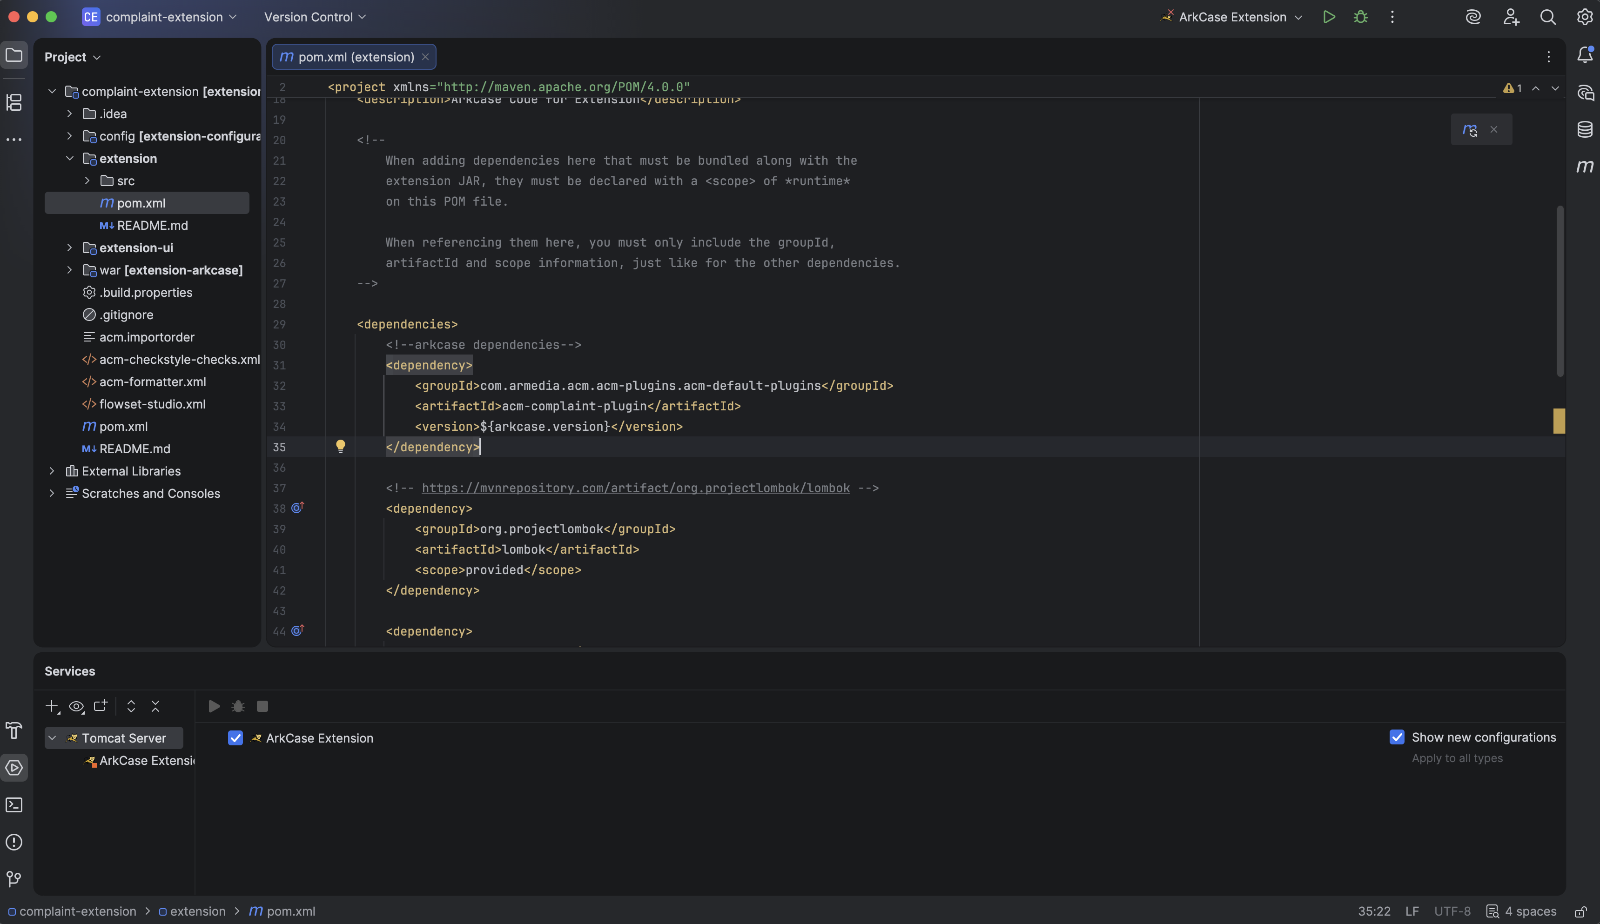

Now, in ArkCase Core project, navigate to the core Complaint.java class to take a quick look.

…/acm-plugins/acm-default-plugins/acm-complaint-plugin/src/main/java/com/armedia/acm/plugins/complaint/model/Complaint.java
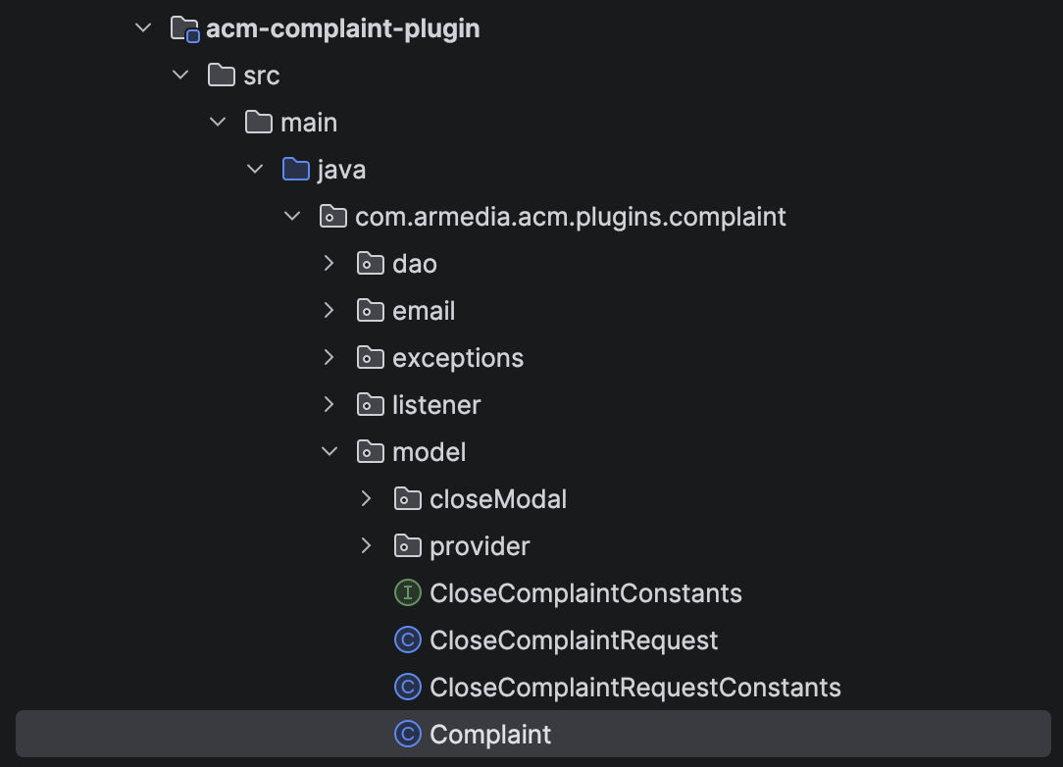

To add a subtitle field to this entity, jump to the extension project. Create ExtComplaint.java class.

…/src/main/java/ext/training/acm/plugins/complaint/model/ExtComplaint.java
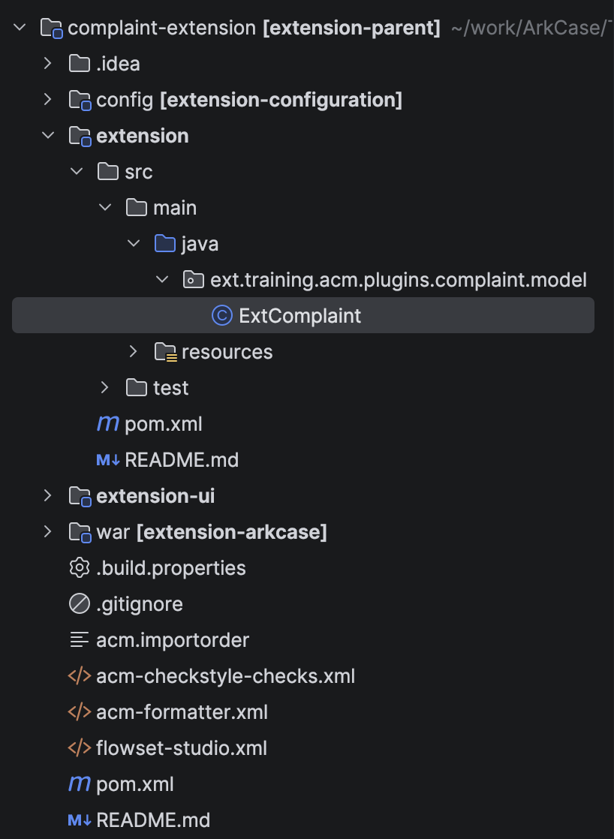

- Extend the core Complaint entity.

public class ExtComplaint extends Complaint {…}

- Add annotations

@Entity
@Table(name = "acm_complaint")
@DiscriminatorValue("ext.training.acm.plugins.complaint.model.ExtComplaint")
@JsonIdentityInfo(generator = JSOGGenerator.class)
@Getter
@Setter
public class ExtComplaint extends Complaint {…}

@Entity allows us to map our class to a table, in this case acm_complaint since the entity is derived.

@Table In which table the extended field is going to show.

@DiscriminatorValue allows us to differentiate between core and extension entities.
com.armedia.acm.plugins.complaint.model.Complaint vs. ext.training.acm.plugins.complaint.model.ExtComplaint

@JsonIdentityInfo(generator = JSOGGenerator.class) allows us to manage circular references.

@Getter
@Setter
Lombok annotations for avoiding getters and setters in the code.

- Add the “subtitle” field.

@Entity
@Table(name = "acm_complaint")
@DiscriminatorValue("ext.training.acm.plugins.complaint.model.ExtComplaint")
@JsonIdentityInfo(generator = JSOGGenerator.class)
@Getter
@Setter
public class ExtComplaint extends Complaint
{
@Column(name = "ext_complaint_subtitle")
private String subtitle;
}
- Add any missing imports and dependencies.

Extend Complaint Database Table

- Add new DB changeset to include the subtitle field
Create extension complaint schema file in extension module in complaint-extension project
…/src/main/resources/ddl/tables/ext-complaint-db-tables-1.0.xml

<databaseChangeLog
xmlns:xsi="http://www.w3.org/2001/XMLSchema-instance"
xmlns="http://www.liquibase.org/xml/ns/dbchangelog"
xsi:schemaLocation="
http://www.liquibase.org/xml/ns/dbchangelog http://www.liquibase.org/xml/ns/dbchangelog/dbchangelog-3.1.xsd">

<changeSet id="ext-complaint-01" author="trainee">
<addColumn tableName="acm_complaint">
<column name="ext_complaint_subtitle" type="VARCHAR(128)"></column>
</addColumn>
</changeSet>

</databaseChangeLog>

Update configuration to accept new package with Entity

Since in the extension project we created a new package where we are adding models, services, APIs, etc … we need to register that package in the configuration to be able all Entities defined in that package to be able to save in the database. Our new package while creating ExtComplaint Entity is ext.training.acm.plugins.complaint.model. let’s register ext.training package as package that will have known Entities that we want to save in database:
- Open configuration file arkcase-custom.yaml in config module in complaint-extension project (here goes all custom configuration properties for the extension)
  - …/src/main/resources/acm-config-server-repo/arkcase-custom.yaml
- Add property jpa.model.packages
  - jpa.model.packages: "com.armedia.**, ext.training.**"
    - com.armedia.** are packages from the Core
    - ext.training.** are packages from the Extension

Register new ExtComplaint entity under Diff Service
We have created Diff Service that check the difference between two objects. To be able to work the service for new created model, we need to register. Open file {training.folder}/ArkCase_Configuration_Training/src/main/resources/acm/acm-config-server-repo/arkcase.yaml. Search for objectDiffConfiguration property and add to the list the following configuration object (NOTE that the configuration is copy of the Complaint configuration, with changed className, name, and added subtitle under includeFields property). This configuration should be added to config/src/main/resources/acm-config-server-repo/arkcase-custom.yaml file in the extension project. Adding with ~ means that the filed objectDiffConfiguration will be merged between the original core configuration file, and custom configuration file in the extension project:
~objectDiffConfiguration:
ext-training-acm-plugins-complaint-model-ExtComplaint:
className: ext.training.acm.plugins.complaint.model.ExtComplaint
name: extComplaint
displayExpression: complaintType + ' ' + complaintTitle
id:
- complaintId
includeFields:
- complaintNumber
- complaintType
- priority
- complaintTitle
- subtitle
- details
- status
- dueDate
- childObjects
- personAssociations
- organizationAssociations
- participants
- addresses
- defaultAddress

Extend Complaint Solr Transformer
ArkCase utilizes Apache SOLR which is an open-source enterprise search solution. You can read more about Apache SOLR at https://lucene.apache.org/solr/.

Dashboard widgets, tree view, search and various grids throughout the application use SOLR data. ArkCase uses SOLR transformers to index data into SOLR. ArkCase also uses SOLR to provide support for access control, facets, pagination, full text indexing etc.

We extended the Complaint entity by adding a subtitle field. To see how a field is indexed into SOLR, navigate to core ComplaintToSolrTransformer.java class.

…/acm-plugins/acm-default-plugins/acm-complaint-plugin/src/main/java/com/armedia/acm/plugins/complaint/service/ComplaintToSolrTransformer.java

We use SolrAdvancedSearchDocument.java helper class to index most common metadata to advanced search core. To index additional metadata, we can use the additionalProperties map as you can see in the transformer.

To extend ComplaintToSolrTransformer and index subtitle field, jump to extension module of complaint-extension project, create ExtComplaintToSolrTransformer.java class.
.../src/main/java/ext/training/acm/plugins/complaint/service/ExtComplaintToSolrTransformer.java

- Extend core ComplaintToSolrTransformer

public class ExtComplaintToSolrTransformer extends ComplaintToSolrTransformer {…}

- Override toSolrAdvancedSearch method to index subtitle field into Advanced Search.
@Override
public SolrAdvancedSearchDocument toSolrAdvancedSearch(Complaint in)
{
SolrAdvancedSearchDocument solr = super.toSolrAdvancedSearch(in);
solr.setAdditionalProperty("subtitle_lcs", ((ExtComplaint)in).getSubtitle());
return solr;
}
- Provide support for indexing extension metadata.

Override the following two methods so that our extension entity is registered for SOLR indexing.

@Override
public boolean isAcmObjectTypeSupported(Class acmObjectType)
{
return ExtComplaint.class.equals(acmObjectType);
}
@Override
public Class<?> getAcmObjectTypeSupported()
{
return ExtComplaint.class;
}

- Register extension transformer with Spring
Create file …/src/main/resources/spring/spring-library-ext-complaint.xml

<?xml version="1.0" encoding="UTF-8"?>
<beans xmlns:xsi="http://www.w3.org/2001/XMLSchema-instance"
xmlns="http://www.springframework.org/schema/beans"
xsi:schemaLocation="http://www.springframework.org/schema/beans http://www.springframework.org/schema/beans/spring-beans-4.1.xsd">
<bean id="extComplaintToSolrTransformer" class="ext.training.acm.plugins.complaint.service.ExtComplaintToSolrTransformer" parent="complaintToSolrTransformer"/>
</beans>

To test this new field, update the My Complaint dashboard configuration to display this new field.

Navigate to ArkCase Core dashboard configuration
…/acm-standard-applications/ui/base-ui/src/main/angular/modules/dashboard/module_config/config.json

Copy it over to the complaint-extension project, in extension-ui module at
…/src/main/angular/modules/dashboard/module_config/

Look for ID matching myComplaints and add the following
{
"name": "subtitle_lcs",
"displayName": "dashboard.widgets.myComplaints.table.header.subtitle",
"headerCellFilter": "translate"
}

Add the display name entry in dashboard label file. To extend the core dashboard label file, create empty dashboard-en-custom.yaml file on the complaint-extension project in the config module at the same path as it is in the ArkCase Core Configuration: src/main/resources/acm/acm-config-server-repo\labels\dasboard-en-custom.yaml, and add this:

~dashboard:
~widgets:
~myComplaints:
~table:
~header:
subtitle: "Subtitle"
In the next image, you can see how the ArkCase SOLR schema is configured. In our case subtitle_lcs would correspond to data type alpha_numeric_sort. You can go through the core transformer code to see how some other data types are indexed.

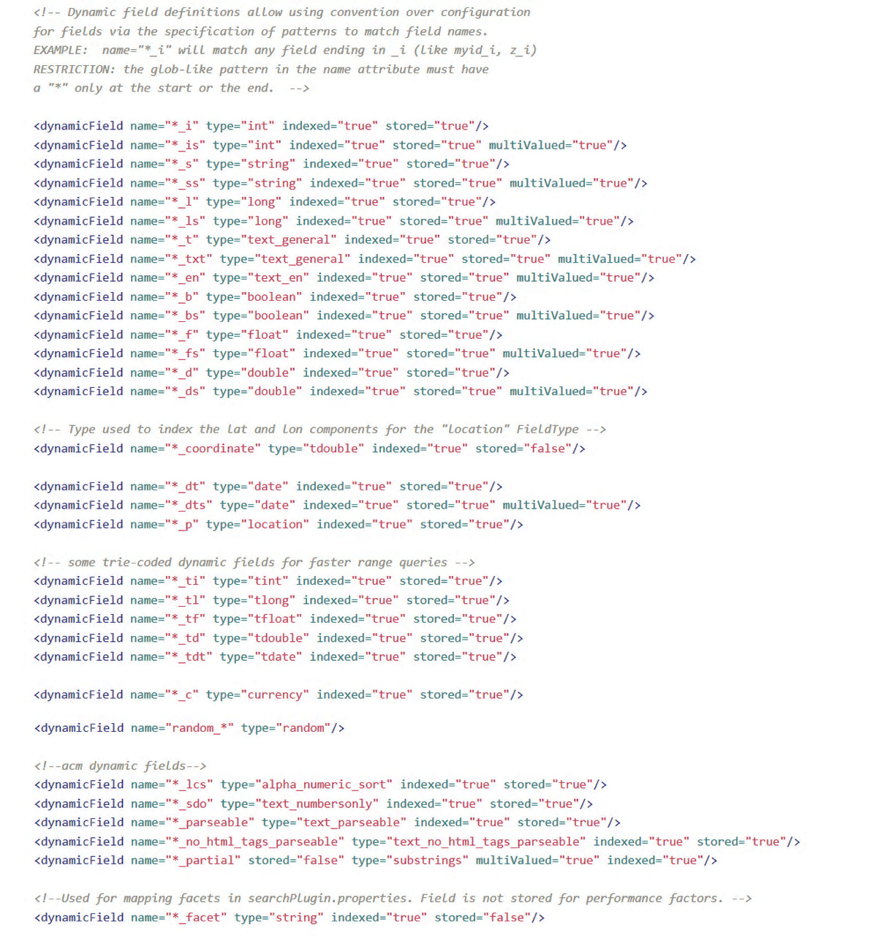

To add the subtitle facet to ArkCase search, simply do the following steps:
- Navigate to the ArkCase Core Configuration arkcase.yaml file src/main/resources/acm/acm-config-server-repo/arkcase.yaml. Go to the search.plugin property in Search Plugin configuration
- Copy search.plugin property together with facet property, and add to complaint-extension project in the config module: src/main/resources/acm/acm-config-server-repo/arkcase-custom.yaml
- Add subtitle_facet property at the end of facet search filed. See the subtitle_facet property below where is located in that structure (NOTE that facet property is starting with { and ending with }):
search.plugin:
facet: |
{
…,
…,
"subtitle_facet": "Subtitle"
}

Extend Complaint UI
In step 1, we added the subtitle field to our extension POJO. Now, we will add this field to the UI.

Unlike backend core entities, UI modules are extended by copying over the desired file (HTML, JS, JSON, etc.) into the extension project and customizing them.

In the extension project (complaint-extension), we have extension-ui module. Every UI folder in the extension must match exactly what is in the ArkCase Core UI and files copied over from core should go in the same directory in the extension as they were originally in core.

Navigate to the complaints UI folder in ArkCase Core.

…/acm-standard-applications/ui/acm-base-ui/src/main/angular/modules/complaints

Take a moment to go through core UI folder structure before moving forward.

Navigate to the core complaints view components folder.

…/acm-standard-applications/ui/acm-base-ui/src/main/angular/modules/complaints/views/components

Copy over complaint-new-complaint-modal.client.view.html and complaint-info.client.view.html files to the complaint-extension project and place them inside extension-ui module in the following folder (create the folder structure): …/src/main/angular/modules/complaints/views/components
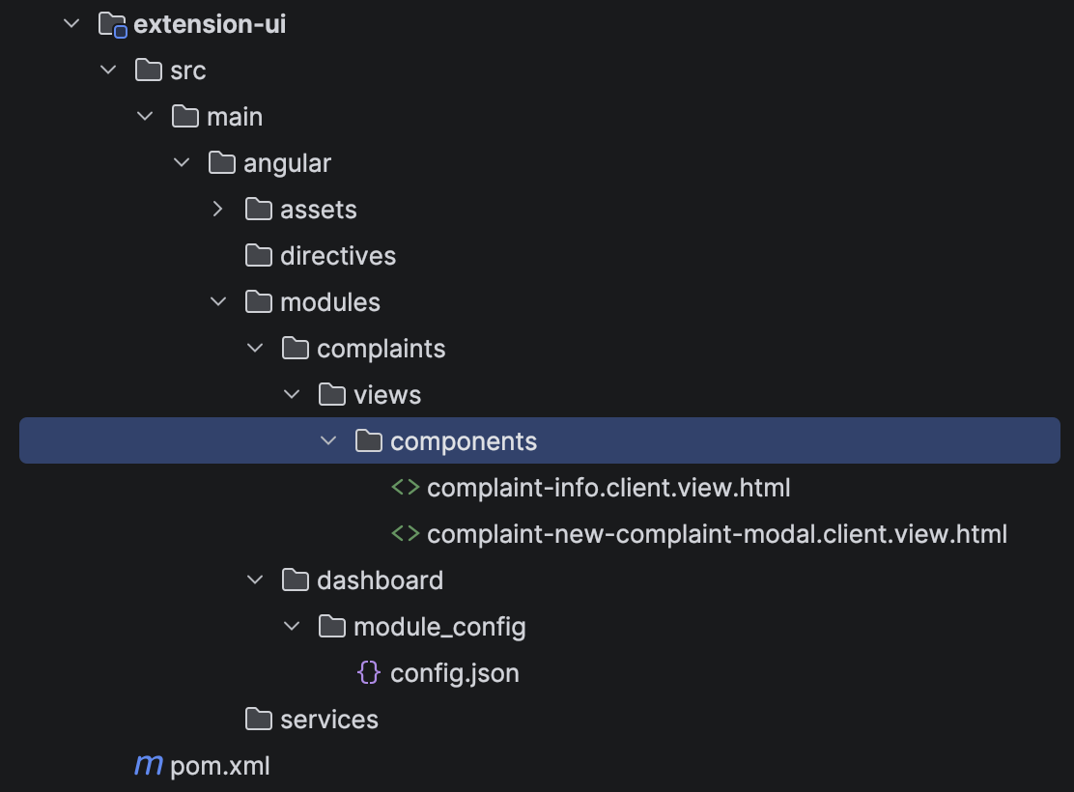

  - Add subtitle field to New Complaint form

In the complaint-new-complaint-modal.client.view.html, below the title row div, add the following code :
<div class="row">
<div class="col-sm-12 form-group">
<label translate>complaints.comp.newComplaint.complaintSubtitle</label>
<input type="text" ng-model="complaint.subtitle" class="input-md form-control"
placeholder="{{ 'complaints.comp.newComplaint.complaintSubtitle.placeholder' | translate }}">
</div>
</div>

  - Update label resources

If you have a look at the above code, there are entries such as :

complaints.comp.newComplaint.complaintSubtitle

These are externalized label entries that you can modify through the Admin UI. These are also useful for internationalization purposes.

Navigate to ArkCase Core Configuration complaint label file.

{training.folder}/ArkCase_Configuration_Training/src/main/resources/acm/acm-config-server-repo/labels/complaints-en.yaml

Find key complaints.comp.newComplaint and below complaintTitle entries. Now we need to add two new labels in the extension in the file named complaints-en-custom.yaml. Let’s create the file and add the lables:
  - The file should be in this location in complaint-extension, in config module:
    - src/main/resources/acm/acm-config-server-repo/labels/complaints-en-custom.yaml
  - Add the following labels:
    - ~complaints.comp.newComplaint:
complaintSubtitle: "Complaint Subtitle"
complaintSubtitle.placeholder: "Enter Complaint Subtitle"

  - Add subtitle field to Complaint Details page

In the complaint-info.client.view.html, below the title div, add the following code:
<div class="row">
<div class="col-xs-6">
<h4>
<a href="#" editable-text="objectInfo.subtitle" onaftersave="saveComplaint()">
{{objectInfo.subtitle}}
</a>
</h4>
</div>
</div>

  - Update configuration

Navigate to ArkCase Core UI.

…/acm-standard-applications/ui/acm-base-ui/src/main/angular/modules/complaints/module_config/config.json

Copy it over to the complaint-extension project in the extension-ui module:

…/src/main/angular/modules/complaints/module_config/

Find the following line :

"className": "com.armedia.acm.plugins.complaint.model.Complaint"

Replace with :

"className": "ext.training.acm.plugins.complaint.model.ExtComplaint"

Build and Start Complaint Extension
Clean build your extension project with the following command.

mvn clean install

After you see successful build, start tomcat through your Intellij IDEA.

Create New ArkCase Module

New Module

Today we are going to create a brand new ArkCase module.

- Backend
  - create a custom entity
  - create backend services
    - DAO
    - Services
    - SOLR Transformer
  - create API
- Frontend
  - create UI module
    - Navigation
      - New Menu
      - Tree Node
      - Ribbon
    - New Form
    - Details View
    - Participants and History UI-Grids
    - Helper Utilities
- Configuration
  - update configurations
    - Roles and Privileges
    - Access Control

As you can see from the agenda above, creating an ArkCase module involves various components.

Let’s build a Comments module with some of the requirements as follow:

- User should be able to create a comment linked to a complaint.

- Any action to a comment should be audited.

- User should be able to add participants to comments so that they can provide exclusive access.

- User should be able to edit a comment

- User should be able to delete a comment

Split the tasks into three steps – entity, user interface and configuration

Comment Entity

  - Folder Structure

When you set up a folder structure for the entity, you are free to come up with a structure that works for you. For this training, we will follow the structure below.

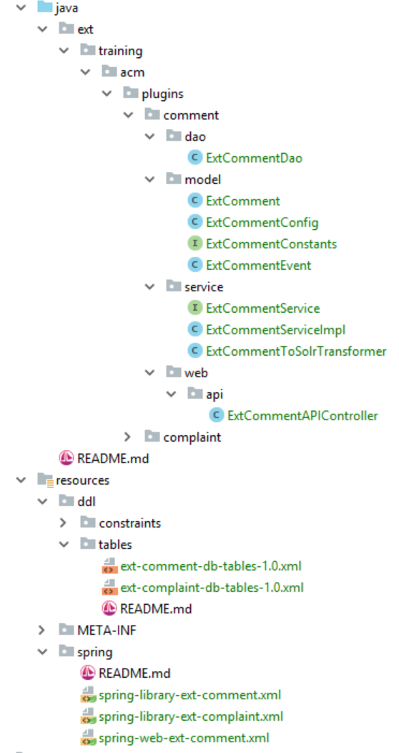

  - Model

Create a simple comment model with a few key fields. A comment must have object ID, object type, details, parent ID, parent type, creator, created, modifier and modified fields.

Let’s create the model ExtComment.java and the interface ExtCommentConstants.java that will keep object type as string.

ExtComment.java
ExtCommentConstants.java

Notice that ExtComment.java implements interfaces AcmObject, AcmEntity and AcmAssignedObject.

  - DB Schema

Create a DB table for comment, add all the columns and constraints as required.

ext-comment-db-tables-1.0.xml

  - DAO

Extend the core AcmAbstractDao abstract class to quickly ramp up your new DAO.

ExtCommentDao.java

  - Service

The service will contain three methods – save, find by ID and delete by ID.

ExtCommentService.java
ExtCommentServiceImpl.java

  - SOLR Transformer

Index fields to the Advanced Search core.

ExtCommentToSolrTransformer.java

In the transformer, you will notice a new entity - AcmUser. This is the representation of a user in ArkCase.

  - API Controller

Create a simple controller with three operations – save, find by ID and delete by ID. Since one of the requirements is to audit events, implement Spring’s ApplicationEventPublisherAware interface and use custom ExtCommentEvent to publish the events. Note that ExtCommentEvent extends AcmEvent which provides various fields that can be easily audited in the application.

ExtCommentAPIController.java
ExtCommentEvent.java

  - Dependency Management

Finally, wire everything together with Spring.

spring-library-ext-comment.xml
spring-web-ext-comment.xml

User Interface (UI)

- Folder Structure

Unlike the backend folder structure, the frontend folder structure must follow a specific pattern. Every subfolder must match exactly what is in the core and files copied over from core should go in the same directory in the extension that they were originally copied from the core. Every UI module consists of following folders:

- config
Contains Angular routes and menu configurations.

- controllers
Contains Angular controller code

- module_config
Contains JSON configurations related to the UI and the label resources used in the HTML views.

- services
Contains module specific services code

- views
Contains module specific HTML views code

Let’s create the new module comments folder in extension-ui module in complaint-extension project with the folder structure explainer above:

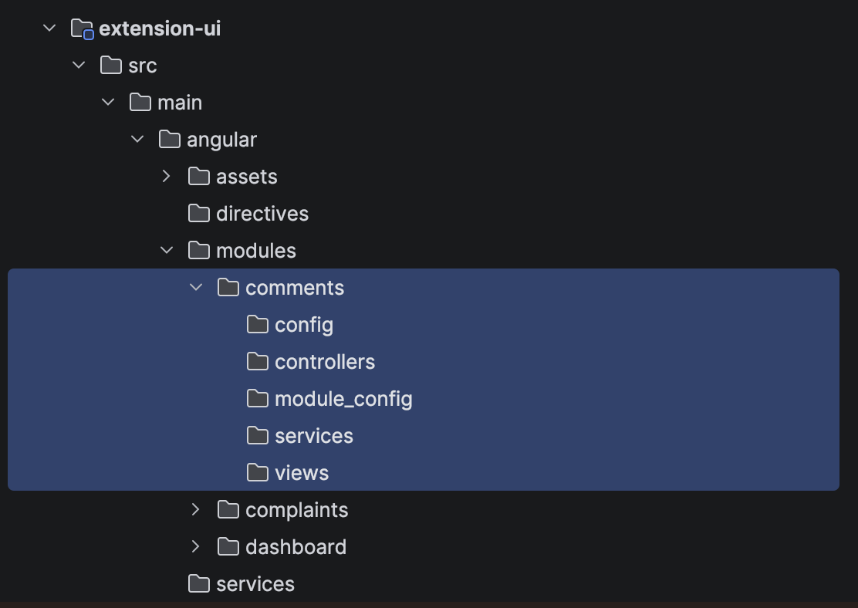

From this point onwards, we assume you have previous knowledge of AngularJS.

- Routes

Set up UI routes and initialization for nodes and menus in extension-ui:

…/src/main/angular/modules/comments/config

comments.client.config.js
comments.client.routes.js

- UI Config

Start by creating the configuration and label files.

…/src/main/angular/modules/comments/module_config/config.json

config.json

In this file, add JSON configuration for the following items.

- Menu items (top and left navigation items)
- Tree view (nodes, filters, sorters)
- View components (UI-grids, summernote etc.)

Before proceeding to the next step, take some time to go through the configurations and understand how everything is set up. We have configured a Summernote view to display the details, a participant grid to display the participants of the comment and a history grid to display audit events. Once you’ve laid out the configuration files, start setting up controllers, views and service components.

- Controller Components

For this training, keep each component in its own JS file. For “New Comment” form, details, participants, tree and content, create a controller each. For history, utilize a UI-route to point to the object history directive.

Create the following controllers into …/src/main/angular/modules/comments/controllers

comments.client.controller.js
comments-list.client.controller.js

These controllers retrieve tree data and individual comment data. We make use of HelperObjectBrowserService core helper service in both cases. Take some time to review these two controllers. Helper functions in the ArkCase Core are in …/acm-standard-applications/ui/acm-base-ui/src/main/angular/services/helper and are available for you to use.

There are a plethora of other services and utilities located in the ArkCase Core at …/acm-standard-applications/ui/acm-base-ui/src/main/angular/services. Feel free to explore at your own pace.

Create the following controllers into …/src/main/angular/modules/comments/controllers/components

comments-details.client.controller.js
comments-participants.client.controller.js

As mentioned previously, these controllers are for details, participants, tree and content components. Note that history and participant UI-grids are generated using ArkCase directives.

Create the following controllers into …/src/main/angular/modules/comments/controllers/components/dialogs

new-comment-modal.client.controller.js

- View Components

We need a modal dialog for New Comment form, views for the details, participants, tree and comment content components. History and participant views make use of object history and participant directives.

Create the following views into …/src/main/angular/modules/comments/views

comments.client.view.html
comments-list.client.view.html

Create the following views into …/src/main/angular/modules/comments/views/components

comments-participants.client.view.html
comments-details.client.view.html

Create the following views into …/src/main/angular/modules/comments/views/components/dialogs

new-comment-modal.client.view.html

- Service Component

According to our requirements, we need to be able to retrieve create, retrieve and delete comments.

Create the following services into …/src/main/angular/modules/comments/services

comments-info.client.service.js
comments-list.client.service.js

- Extend Object Mapping

Copy the file from Core in the location acm-standard-applications/ui/acm-base-ui/src/main/angular/services/object/object-lookup.client/service.js in the folder …/src/main/angular/services/object in extension project

object-lookup.client.service.js

And add the following line after line 337:

case "COMMENT":

Finally register the module with Angular.

Create the following services into …/src/main/angular/modules/comments

comments.client.config.js

Configuration

Finally, configure privileges and access control for the new Comment module.

- Register New Module

Add the new extension packages under jpa.model.packages in extension project in config/src/main/resources/acm/acm-config-server-repo/arkcase-custom.yaml file (you can skip this step since we already did that when we were working on extending Complaint module, and we are using the same package structure for this module as well)

jpa.model.packages: "com.armedia.**, ext.training.**"

Let’s register the plugin and where to show the actions for that plugin. Copy app-config.xml from ArkCase Core Configuration located in src/main/resources/acm to extension project in config module in the folder src/main/resources/acm. Add the following config to that file in extension project:

In "topbarActions" block, add :

<ref bean="createCommentAction"/>

In "<!-- top bar buttons -->" block, add :

<bean id="createCommentAction" class="com.armedia.acm.core.AcmUserAction">
<property name="actionName" value="Comment"/>
<property name="actionResourceName" value="common:top-bar.button.comment"/>
<property name="requiredPrivilege" value="ext-comment-module"/>
</bean>

In "navigatorTabs" block, add :

<ref bean="commentNavigatorAction"/>

In "<!-- navigator tabs -->" block, add :

<bean id="commentNavigatorAction" class="com.armedia.acm.core.AcmUserAction">
<property name="actionName" value="Comment"/>
<property name="actionResourceName" value="common:navigation.label.comment"/>
<property name="requiredPrivilege" value="ext-comment-module"/>
</bean>

In "objectTypes" block, add :

<ref bean="commentType"/>

In "<!-- begin of objectTypes -->" block, add:

<bean id="commentType" class="com.armedia.acm.core.AcmObjectType">
<property name="name" value="COMMENT"/>
<property name="description" value="Comment"/>
<property name="iconName" value="fa fa-comment"/>
<property name="url">
<map>
<entry key="COMMENT" value="/home.html#!/comments"/>
</map>
</property>
</bean>

Open src/main/resources/acm/acm-config-server-repo/arkcase-custom.yaml in the extension project in config module, and add the following configuration:

~navigator:
comments:
name: "Comments"
iconName: "fa fa-comment"
privilege: "extCommentModulePrivilege"
privilegeName: "ext-comment-module"

Add the following configuration in the same file for the tree sorters and:

comment.plugin:
search.tree:
filter: "[{\"desc\": \"All Open Comments\", \"name\":\"all-open-comments\", \"value\":\"fq=-status_s:COMPLETE AND -status_s:DELETE AND -status_s:CLOSED\", \"default\":true}
,{\"desc\": \"All I've Created\", \"name\":\"my-comments\", \"value\":\"fq=author_s:$[user]\"}
,{\"desc\": \"(No Filter)\", \"name\":\"\", \"value\":\"\"}]"
sort: "[{\"desc\": \"Sort Created Date Asc\", \"name\":\"sort-created-date-asc\", \"value\":\"create_tdt ASC\"}
,{\"desc\": \"Sort Created Date Desc\", \"name\":\"sort-created-date-desc\", \"value\":\"create_tdt DESC\", \"default\":true}
,{\"desc\": \"Sort By Name\", \"name\":\"sort-by-name-asc\", \"value\":\"title_parseable_lcs ASC\"}
,{\"desc\": \"(No Sort)\", \"name\":\"\", \"value\":\"\"}]"
#The properties where the search query should be executed (comma separated, for example: title_parseable,description_no_html_tags_parseable ... etc)
searchQuery: "title_parseable_lcs"

Add the following config POJO to …/src/main/java/ext/training/acm/plugins/comment/model/ExtCommentConfig.java to represent above configuration.

ExtCommentConfig.java

- Add labels files in extension project in config module in this location: src/main/resources/acm/acm-config-server-repo/labels
comments-en.yaml
NOTE: for other languages, you copy this file and translate the values of the keys in this document. For example for French, you will need a copy of this file with the name comments-fr.yaml

- Update Roles and Privilege
Open src/main/resources/acm/acm-config-server-repo/arkcase-custom.yaml in the extension project in config module, and add the following configuration to register new privileges:

~privileges:
extCommentPrivilege: Comment Privilege
extCommentModulePrivilege: Comment Module Privilege

Add ROLE_ADMINISTRATOR in the application.rolesToPrivileges to provide the above privileges to all the roles:

~application:
~rolesToPrivileges:
~ROLE_ADMINISTRATOR:
- extCommentPrivilege
- extCommentModulePrivilege

- Add URL Privileges

Open src/main/resources/acm/acm-config-server-repo/arkcase-custom.yaml in the extension project in config module, and add the following configuration to register new URL privileges:

~acmPluginConfigurationPrivileges:
extCommentPrivilege:
GET:
- "/api/{version}/plugin/ext/comment/{id}"
POST:
- "/api/{version}/plugin/ext/comment"
DELETE:
- "/api/{version}/plugin/ext/comment/{id}"
extCommentModulePrivilege:
GET:
- "/modules/comments/views/"

- Update Drools Rules

First, let’s copy the drools files from ArkCase Core Configuration to Extension Project. Then we will add the rules for the Comment module.

Copy these files from ArkCase Core Configuration:
  - src/main/resources/acm/acm-config-server-repo/rules/drools-assignment-rules.drl
  - src/main/resources/acm/acm-config-server-repo/rules/drools-access-control-rules.drl

Into this folder in extension project in the config module:
  - src/main/resources/acm/acm-config-server-repo/rules

Add the following new rules to set the creator of the comment as the assignee. These rules goes at the end of the drools-assignment-rules.drl:

// rule values at C49, header at C16
rule "Assignment Rules_49"
salience 65507
when
$acmObject: AcmAssignedObject(objectType.equals("COMMENT"))
eval(evalBoolean("participants.?[participantType == 'assignee'].isEmpty()", $acmObject))
then
addParticipantExpression($acmObject, "assignee", "new String('')");
end

rule "Assignment Rules_50"
salience 65506
when
$acmObject: AcmAssignedObject(objectType.equals("COMMENT"))
eval(evalBoolean("participants.?[participantType == '*'].isEmpty()", $acmObject))
then
addParticipant($acmObject, "*", "*");
end

Add three new rules to grant read access to appropriate participants. These rules goes at the end of the drools-access-control-rules.drl

// rule values at C107, header at C15
rule "Access Control Rules_107"
salience 65448
when
$acmObject: AcmAssignedObject(objectType.equals("COMMENT"))
eval(evalSpring("restricted", $acmObject))
then
setAccess($acmObject, "deny read to *");
end

// rule values at C108, header at C15
rule "Access Control Rules_108"
salience 65447
when
$acmObject: AcmAssignedObject(objectType.equals("COMMENT"))
then
setAccess($acmObject, "mandatory deny read to No Access");
end

// rule values at C22, header at C15
rule "Access Control Rules_109"
salience 65546
when
$acmObject: AcmAssignedObject(objectType.equals("COMMENT"))
eval(evalSpring("status != 'DRAFT'", $acmObject))
then
setAccess($acmObject, "grant read to *");
end

- Update Audit Properties

In the ExtCommentEvent.java class, the base event type for auditing comment is ext.training.acm.plugins.comment. Possible actions can be customized. For now, we set available event types in ExtCommentConstants.java class.
Let’s extend common-en.yaml file to be able to add the new events.
  - Create the file in extension project in config module: src/main/resources/acm/acm-config-server-repo/labels/common-en-custom.yaml file.

eventType.ext.training.acm.plugins.comment.event.create: Comment Created
eventType.ext.training.acm.plugins.comment.event.update: Comment Updated
eventType.ext.training.acm.plugins.comment.event.delete: Comment Deleted

If you want to provide custom description instead of plain messages like above, when creating audit event, in your code simply set:

extCommentEvent.setEventDescription(“custom description”);

For the events to show up in the history grid, go to file src/main/resources/acm/acm-config-server-repo/arkcase-custom.yaml and add the following entry:

COMMENT.history.event.types: "ext.training.acm.plugins.comment.event.create,ext.training.acm.plugins.comment.event.update,ext.training.acm.plugins.comment.event.delete"

The pattern is objectType.history.event.types: “List of event types separated by comma”.

And at the end, we need to add left navigation menu and top bar section in the labels. Go to extension project in the module config, and create the file for extending core labels: src/main/resources/acm/acm-config-server-repo/labels/core-en-custom.yaml, and add the following properties:

core:
menus:
leftnav:
comments.main: Comments
topbar:
new-comment: Comment

Clean and build the extension with:
  - mvn clean install

Start Tomcat from the IntelliJ IDEA.

Congratulations! You have successfully created a new module in ArkCase.

